**CREDIT SCORE PREDICTION REPORT  
By NERAV RANGARI**

**1) Data Set Description**

1. **Nature and Context of the Data Set**

This dataset contains financial, credit, and behavioral information about customers. It is suitable for analyzing credit risk, predicting credit scores, or understanding financial behaviors. The dataset includes 29 columns with details such as customer demographics (age, occupation), financials (income, debts, loans), behavioral indicators (payment habits, credit inquiries), and credit score.

**Columns and Corresponding Values**

1. **id**: 0x1602 - Unique identifier for the record.
2. **customer_id**: CUS_0xd40 - Unique identifier for the customer.
3. **month**: January - The month of the record.
4. **name**: Aaron Maashoh - Customer's name.
5. **age**: 23 - Customer's age.
6. **ssn**: 821-00-0265 - Social Security Number.
7. **occupation**: Scientist - Profession of the customer.
8. **annual_income**: 19114.12 - Annual income of the customer.
9. **monthly_inhand_salary**: 1824.8434 - Monthly salary after deductions.
10. **total_emi_per_month**: 49.574947 - Total monthly EMI payments.
11. **num_bank_accounts**: 3 - Number of bank accounts held by the customer.
12. **num_credit_card**: 4 - Number of credit cards owned.
13. **interest_rate**: 3 - Interest rate on loans (presumably in %).
14. **num_of_loan**: 4 - Number of active loans.
15. **type_of_loan**: ['Auto Loan', 'Credit-Builder Loan', 'Personal Loan', 'Home Equity Loan'] - List of loan types the customer has.
16. **delay_from_due_date**: 3 - Average delay in days for loan payments.
17. **num_of_delayed_payment**: 7 - Total number of delayed payments.
18. **changed_credit_limit**: 11.27 - Amount by which the credit limit has changed.
19. **num_credit_inquiries**: 4 - Number of credit inquiries made.
20. **credit_mix**: Good - Quality of the credit mix (e.g., good, bad, etc.).
21. **outstanding_debt**: 809.98 - Total outstanding debt.
22. **credit_utilization_ratio**: 26.82262 - Ratio of credit utilization.
23. **credit_history_age**: 265 - Length of credit history (possibly in months).
24. **payment_of_min_amount**: No - Whether the customer pays the minimum amount on credit card bills.
25. **amount_invested_monthly**: 80.4153 - Monthly investment amount.
26. **payment_behaviour**: High_spent_Small_value_payments - Pattern of payment behavior.
27. **monthly_balance**: 312.49408 - Remaining balance at the end of the month.
28. **credit_score**: 2 - Customer's credit score (scale not provided, but 2 seems low).

**b) Potential Outcomes from Analysis**

* **Credit Risk Assessment**: Identify high-risk customers based on loan delays, outstanding debt, and credit utilization ratio.
* **Segmentation**: Group customers by financial behavior, loan types, or credit scores.
* **Predictive Analytics**: Build a credit score prediction model or identify factors impacting the credit score.
* **Behavior Analysis**: Explore patterns in payment behavior and how they influence financial health.

**c) Initial Data Quality, Integrity, and Ethics Issues**

* **Data Quality**:
  + Missing or incomplete data (e.g., SSN or credit history might is missing for some customers).
  + Inconsistent formats (e.g., loan types listed as strings or lists).
  + type_of_loan is stored as a list, which might complicate analysis. This should be transformed into separate columns for each loan type.
* **Data Integrity**:
  + Duplicate records or mismatched customer IDs.
  + Outliers, such as extremely high or low credit scores or incomes.
* **Data Ethics**:
  + Personally identifiable information (PII) such as name and ssn is included, raising privacy concerns. These should be anonymized or removed for compliance with data privacy laws like GDPR or CCPA.
  + It is unclear if customer consent has been obtained for using this financial and personal data.
  + Using insights to push high-risk loans or exploit financially vulnerable customers is unethical.

2) **Data Preparation / Data Wrangling**

**a) Steps and Outcomes of the Data Preparation Phase**

Data preparation (or data wrangling) is a crucial step in the data analysis process. It involves transforming raw data into a format that is clean, organized, and ready for analysis. Here are the key steps involved:

1. Data Collection: The data is taken from kaggle
2. Data Integration: Combining data from different sources and ensuring consistency and compatibility.
3. Data Cleaning:
   * Handling Missing Data: Identifying and handling missing values using imputation, deletion, or replacement techniques.
   * Correcting Data Errors: Identifying and fixing inconsistencies, duplicate records, or incorrect data entries.
   * Standardization: Ensuring uniformity in data formats (e.g., date formats, text capitalization).
4. Data Transformation:
   * Normalization/Standardization: Scaling data values to a standard range, often to handle differences in units of measurement.
   * Encoding Categorical Variables: Converting categorical data into numerical format using methods like one-hot encoding or label encoding.
   * Feature Engineering: Creating new features or transforming existing ones to improve the predictive power of the data.
5. Data Reduction:
   * Removing Redundant Features: Dropping highly correlated or irrelevant features.
   * Dimensionality Reduction: Reducing the number of variables using techniques like Principal Component Analysis (PCA).
6. Data Splitting: Dividing the dataset into training, testing, and validation sets for model training.

Outcomes:

* Cleaned dataset, free of errors, inconsistencies, and missing values.
* Data is in a uniform format, ready for analysis or modeling.
* Increased model accuracy through feature selection, transformation, and scaling.

**b) Data Profiling Information for Each Data Element**

Data profiling provides insights into the structure, quality, and distribution of data. Key profiling information for each data element includes:

1. Data Type: Identifies the type of data (e.g., integer, float, string, date).
2. Missing Values: Number and percentage of missing values for each column.
3. Unique Values: Number of distinct values in each column.
4. Value Distribution: Summary statistics (mean, median, mode, min, max) for numerical columns.
5. Outliers: Identifying outliers that might skew analysis or modeling.
6. Data Quality Issues: Identification of errors, inconsistencies, or invalid data entries.
7. Relationships: Identifying correlations or dependencies between variables.

**Data Profiling Information for Each Data Element:**

| **Column Name** | **Data Type** | **Non-Null Count** | **Description** |
| --- | --- | --- | --- |
| id | Object | 100,000 | Unique identifier for records. |
| customer_id | Object | 100,000 | Unique customer identifier. |
| month | Object | 100,000 | Month associated with the record. |
| name | Object | 100,000 | Customer name. |
| age | Int64 | 100,000 | Customer's age (filled missing values). |
| ssn | Object | 100,000 | Social Security Number. |
| occupation | Object | 100,000 | Customer occupation (filled missing). |
| annual_income | Float64 | 100,000 | Annual income (mean imputation used). |
| monthly_inhand_salary | Float64 | 100,000 | Monthly salary after deductions. |
| total_emi_per_month | Float64 | 100,000 | Monthly EMI payments. |
| num_bank_accounts | Int64 | 100,000 | Number of active bank accounts. |
| num_credit_card | Int64 | 100,000 | Number of credit cards. |
| interest_rate | Int64 | 100,000 | Interest rate on loans. |
| num_of_loan | Int64 | 100,000 | Number of loans. |
| type_of_loan | Object | 100,000 | Type of loans availed. |
| delay_from_due_date | Int64 | 100,000 | Days of delay in payment. |
| num_of_delayed_payment | Int64 | 100,000 | Number of delayed payments. |
| changed_credit_limit | Float64 | 100,000 | Adjustments to credit limits. |
| num_credit_inquiries | Int64 | 100,000 | Number of credit inquiries. |
| credit_mix | Object | 100,000 | Types of credit accounts. |
| outstanding_debt | Float64 | 100,000 | Amount of outstanding debt. |
| credit_utilization_ratio | Float64 | 100,000 | Ratio of credit utilization. |
| credit_history_age | Int64 | 100,000 | Age of credit history in years. |
| payment_of_min_amount | Object | 100,000 | Payment of minimum amount ('Yes'/'No'). |
| amount_invested_monthly | Float64 | 100,000 | Monthly investments made. |
| payment_behaviour | Object | 100,000 | Payment behavior description. |
| monthly_balance | Float64 | 100,000 | Monthly balance after all deductions. |
| credit_score | Int64 | 100,000 | Credit score (integer between 0–2). |
| credit_score_category | Object | 100,000 | Credit score grouped into categories. |

**d. Code**

**a. Import Libraries**

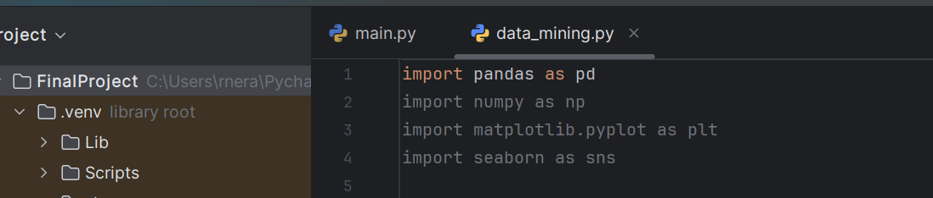

The imported libraries are essential tools for working with data:

* pandas: Handles data as tables (DataFrames).
* numpy: Supports numerical computations (e.g., for statistics or handling arrays).
* matplotlib.pyplot: Creates visualizations like plots and graphs.
* seaborn: Enhances visualizations for statistical insights.

b. Load the Dataset

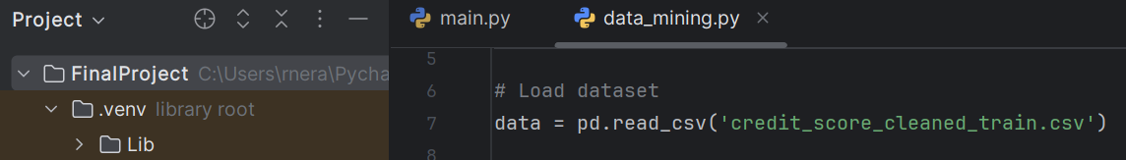

The dataset is loaded into a Pandas DataFrame from a CSV file (credit_score_cleaned_train.csv).

c. Preview the Dataset

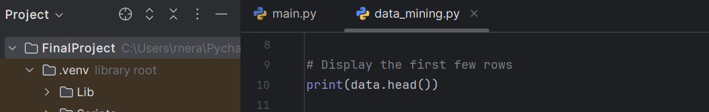

Displays the **first 5 rows** of the dataset

The first few rows and the shape of the dataset are displayed using data.head() and data.shape.

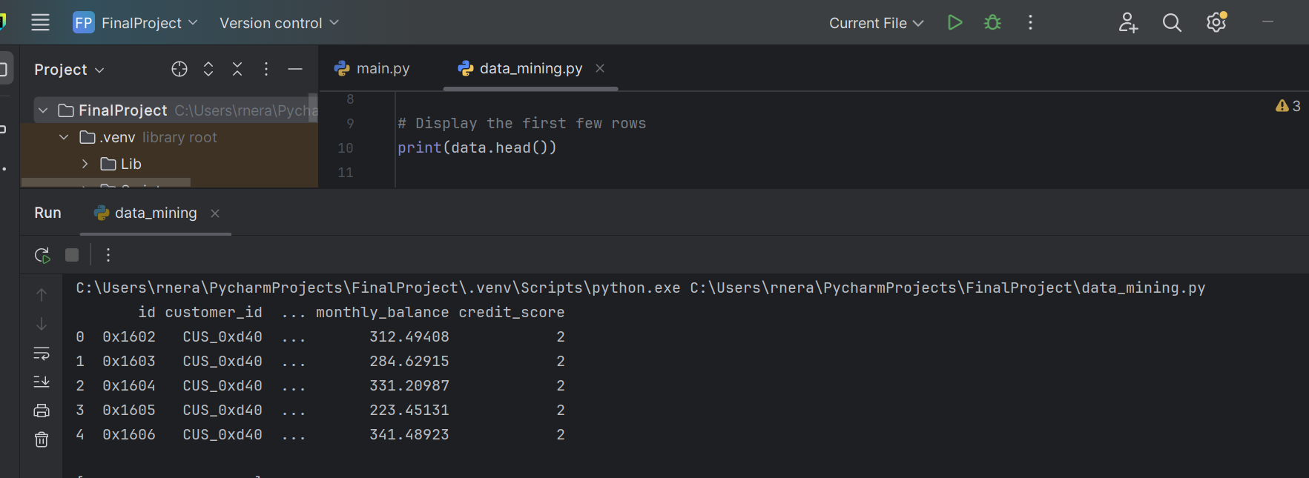

d. Dataset Dimensions

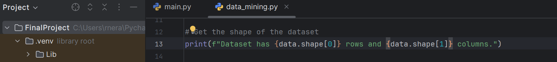

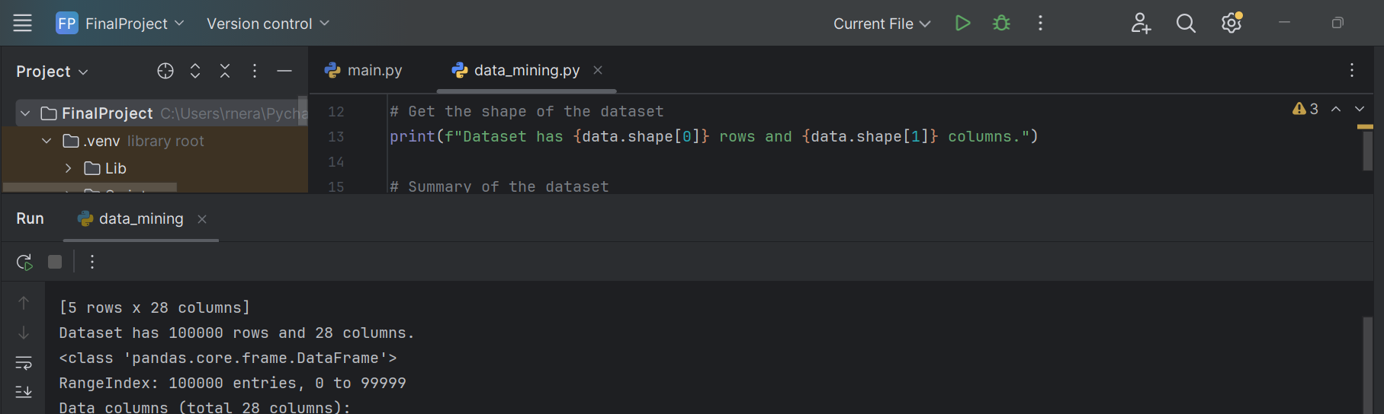

We get the number of entries in row and column.

e. Dataset Overview

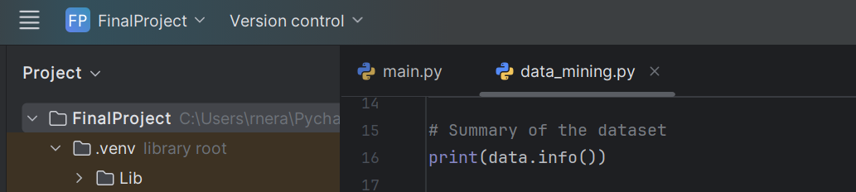

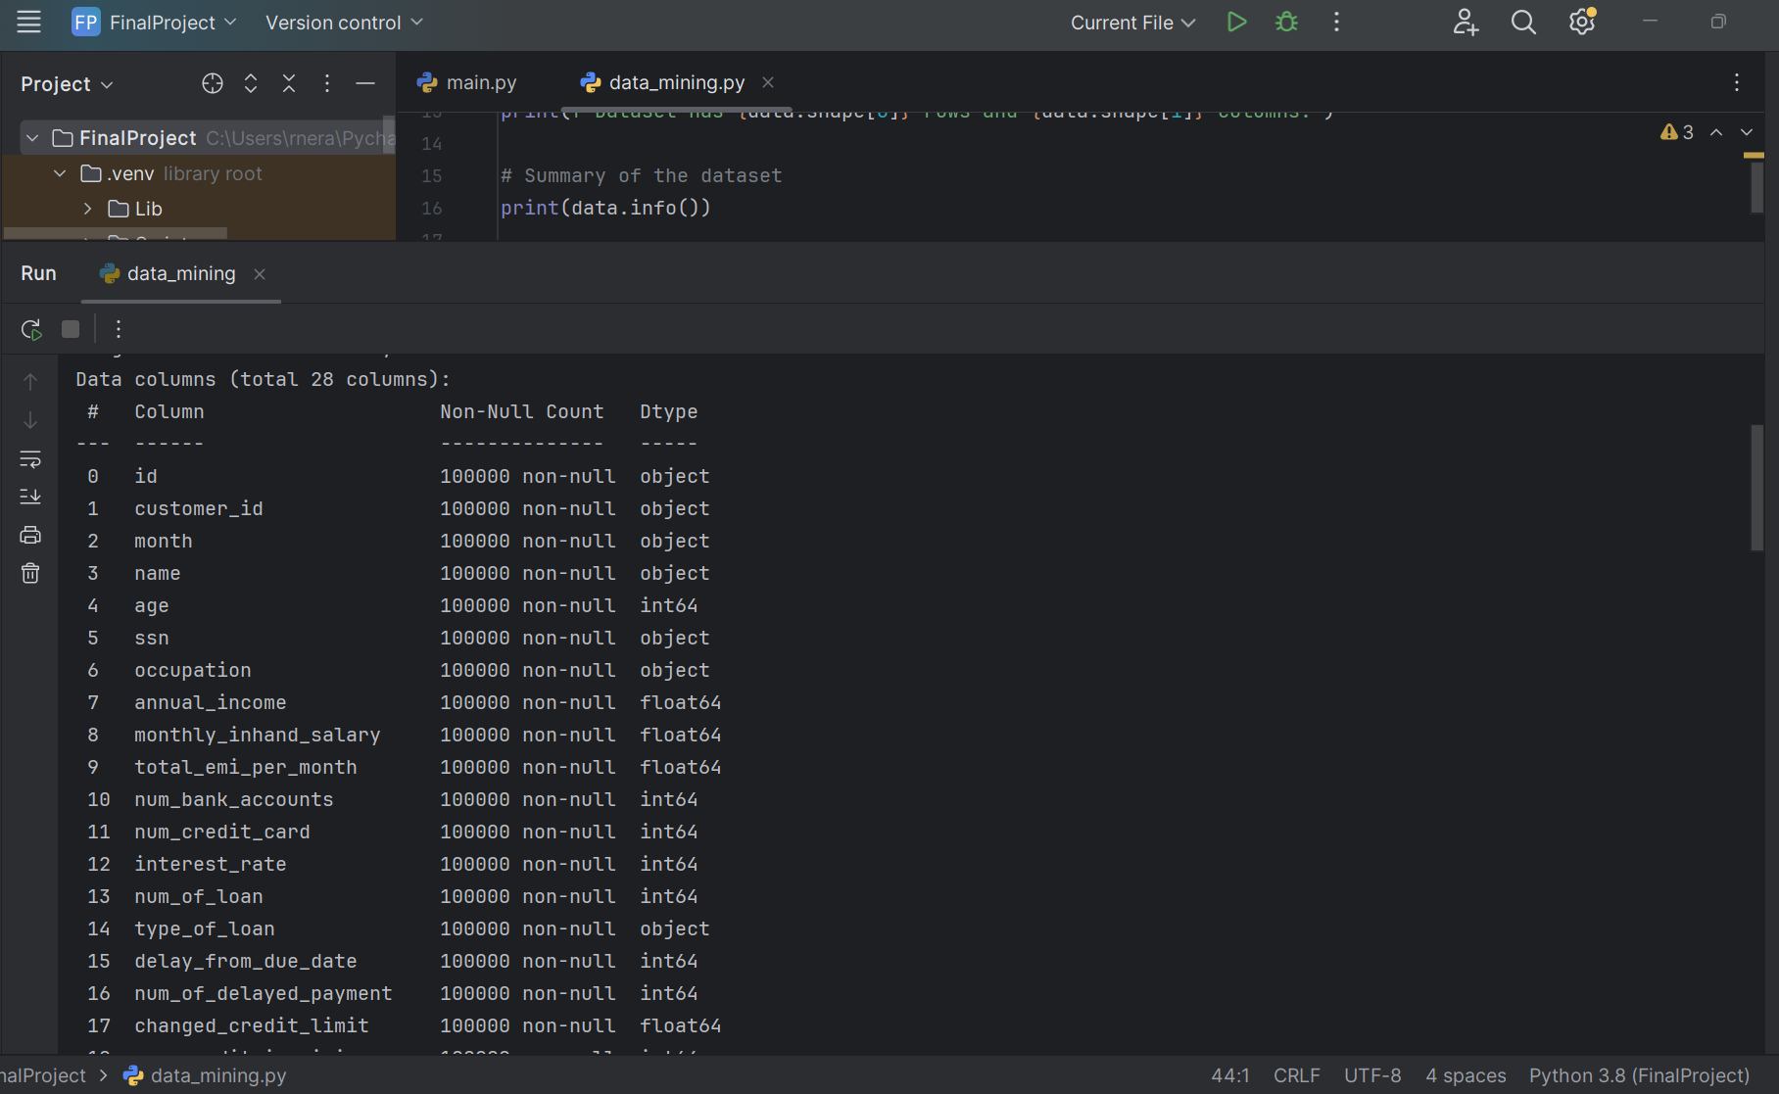

data.info() provides the summary of the dataset, including the number of non-null entries and data types.

f. Statistical Summary

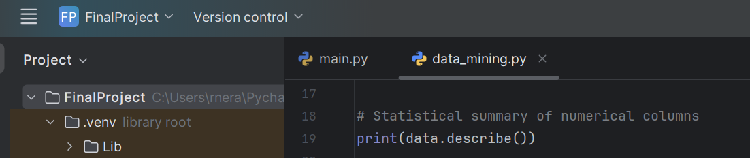

data.describe() gives statistical summaries of numerical columns like mean, min, max, and standard deviation.

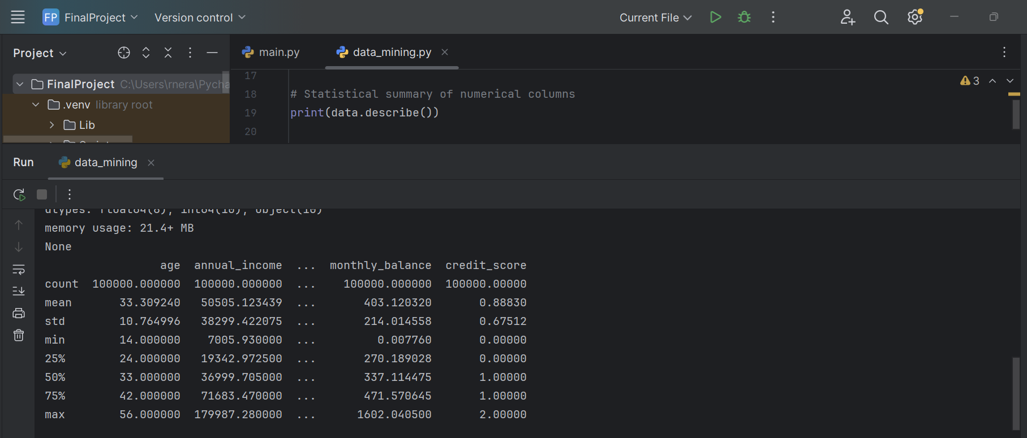

g. Missing Values Check

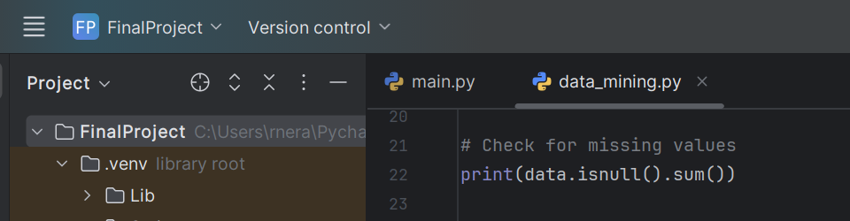

data.isnull().sum() checks for missing values.

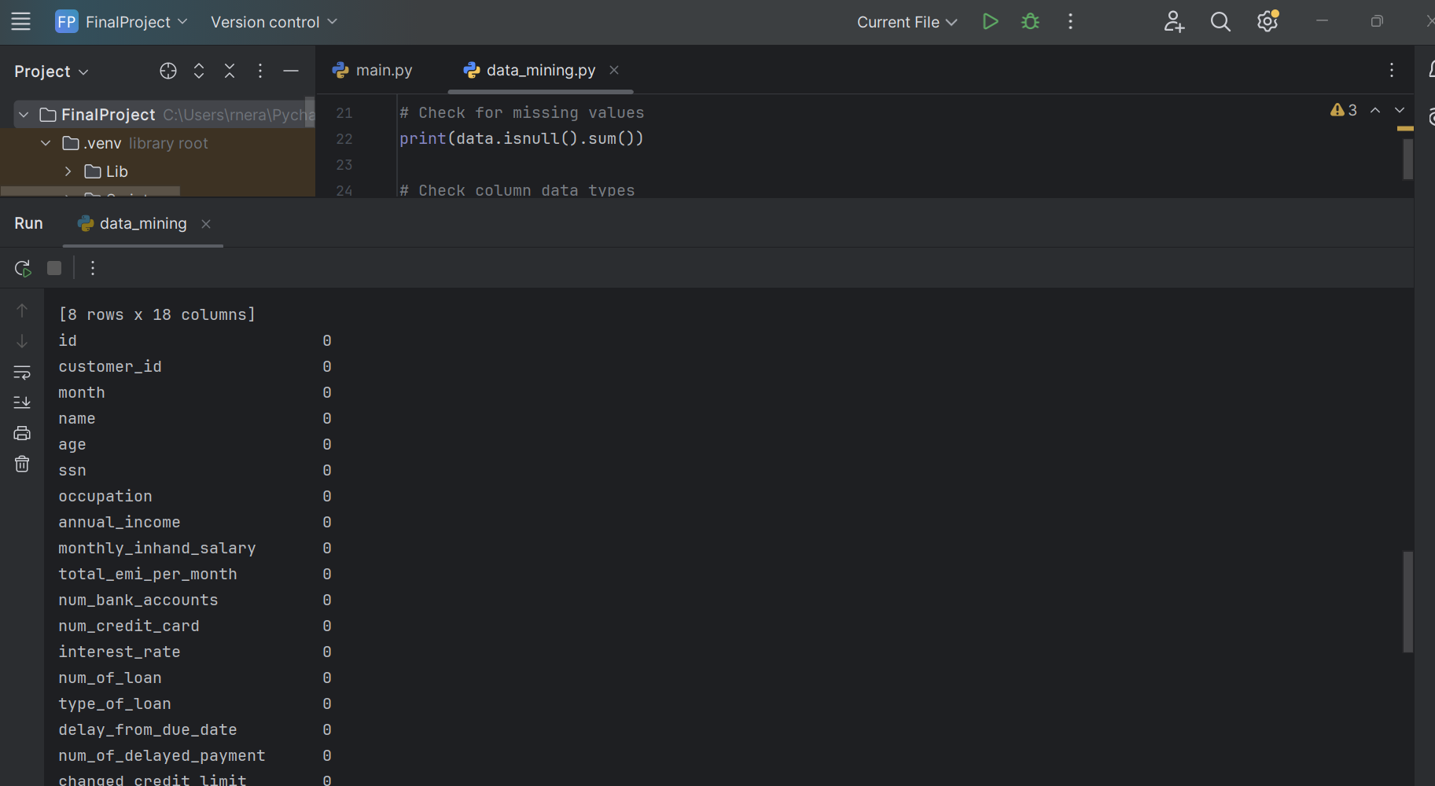

h. Column Data Types

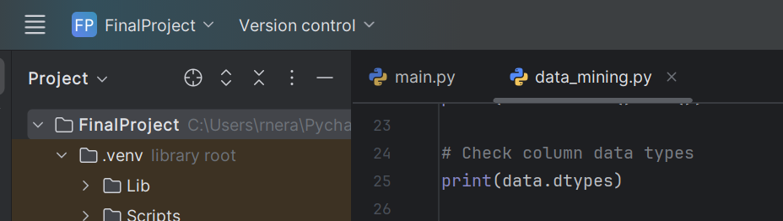

data.dtypes shows the data types of each column.

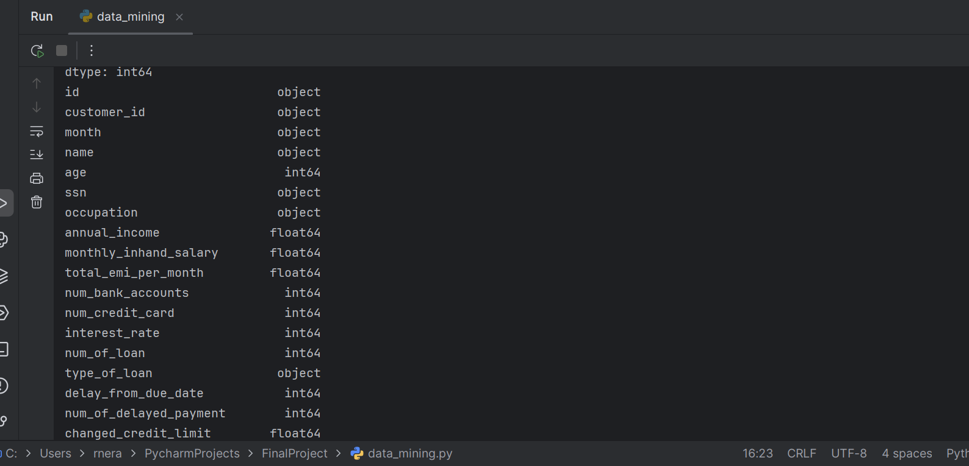

* + 1. Duplicate Values

If there are any duplicates, they would be dropped

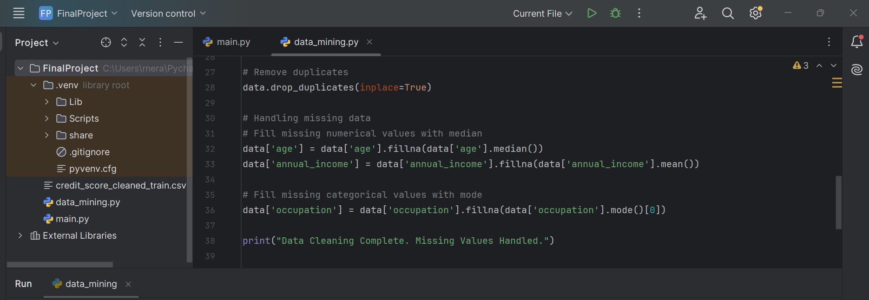

Duplicates are removed using data.drop_duplicates() to ensure no redundancy in the dataset.

j. Boxplot for outliers using IQR

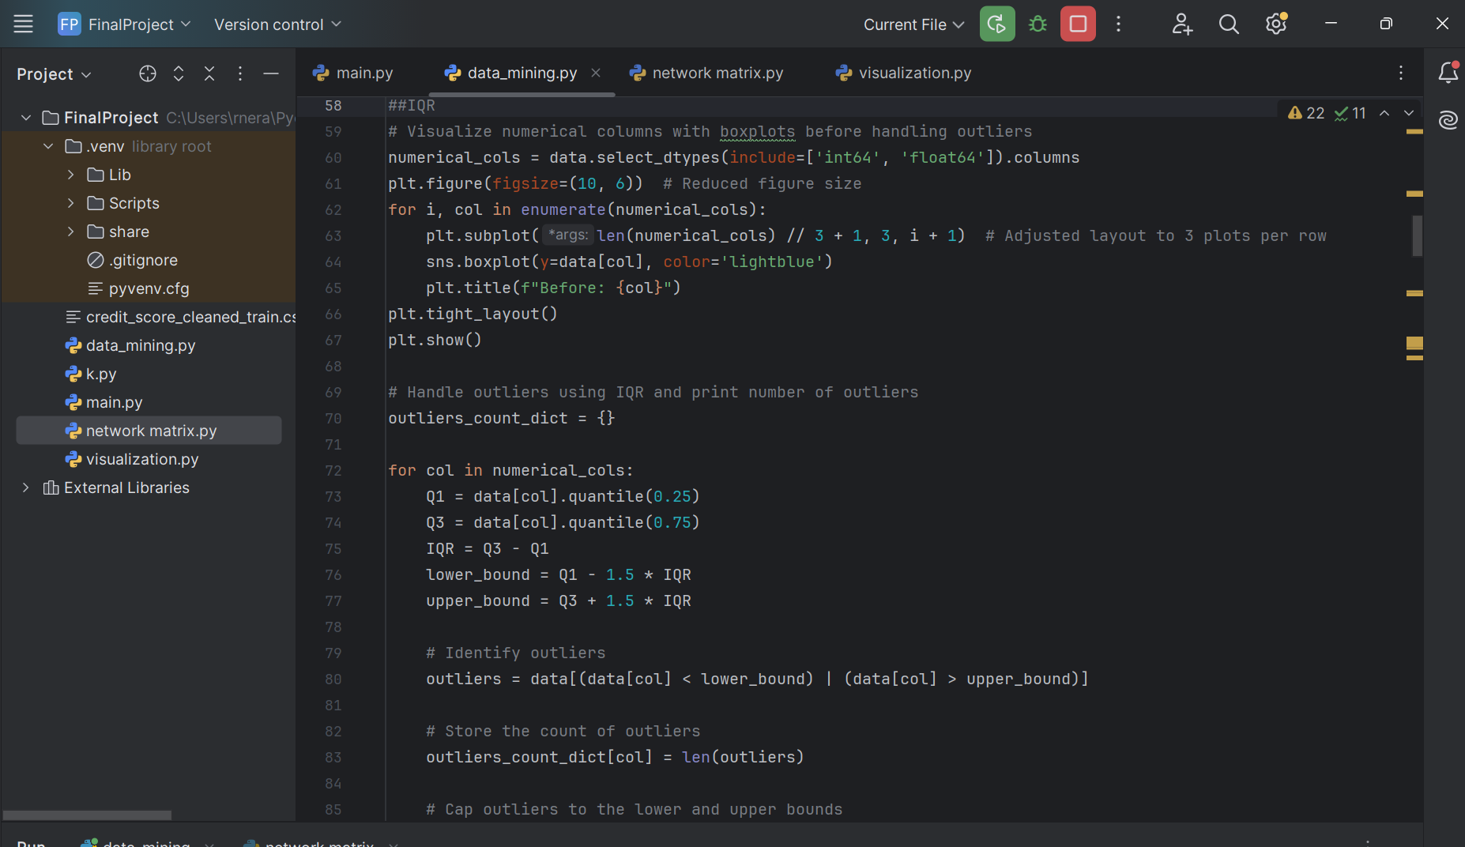

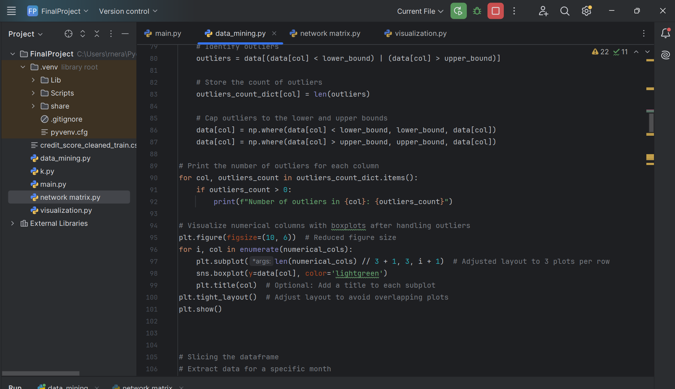

Numerical columns with missing values (age, annual_income) are filled with the median and mean, respectively.

Categorical columns with missing values (occupation) are filled with the mode (most frequent value).

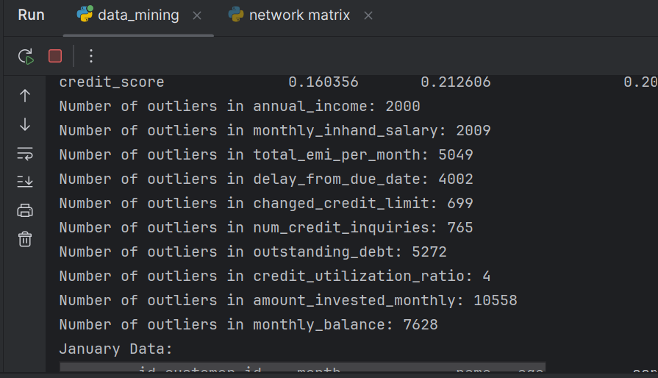

Boxplot before removing the outliers

**Before Handling Outliers**: Boxplots are created for numerical columns to visualize potential outliers.

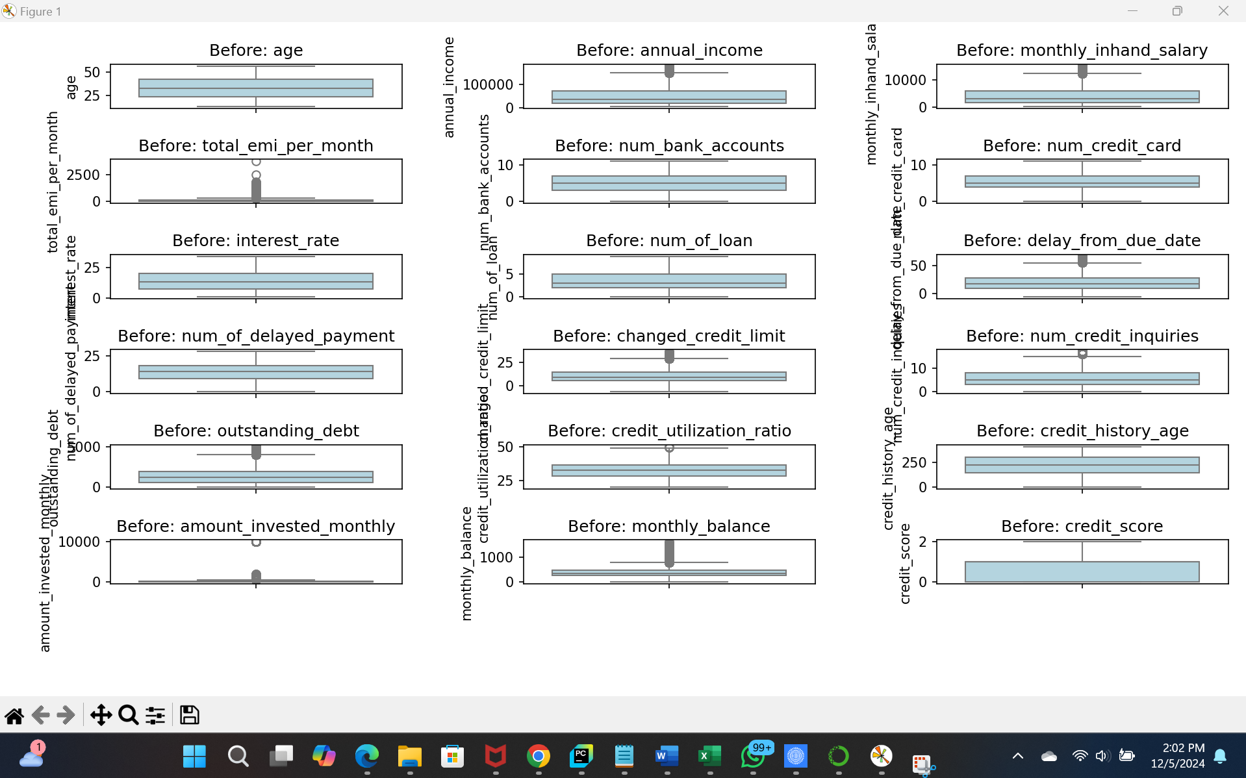

Boxplot after removing the outliers

* **After Handling Outliers**: The Interquartile Range (IQR) method is used to handle outliers by capping values outside the bounds (lower and upper bounds calculated using 1.5 * IQR). After outliers are handled, boxplots are generated again to visually confirm the change.

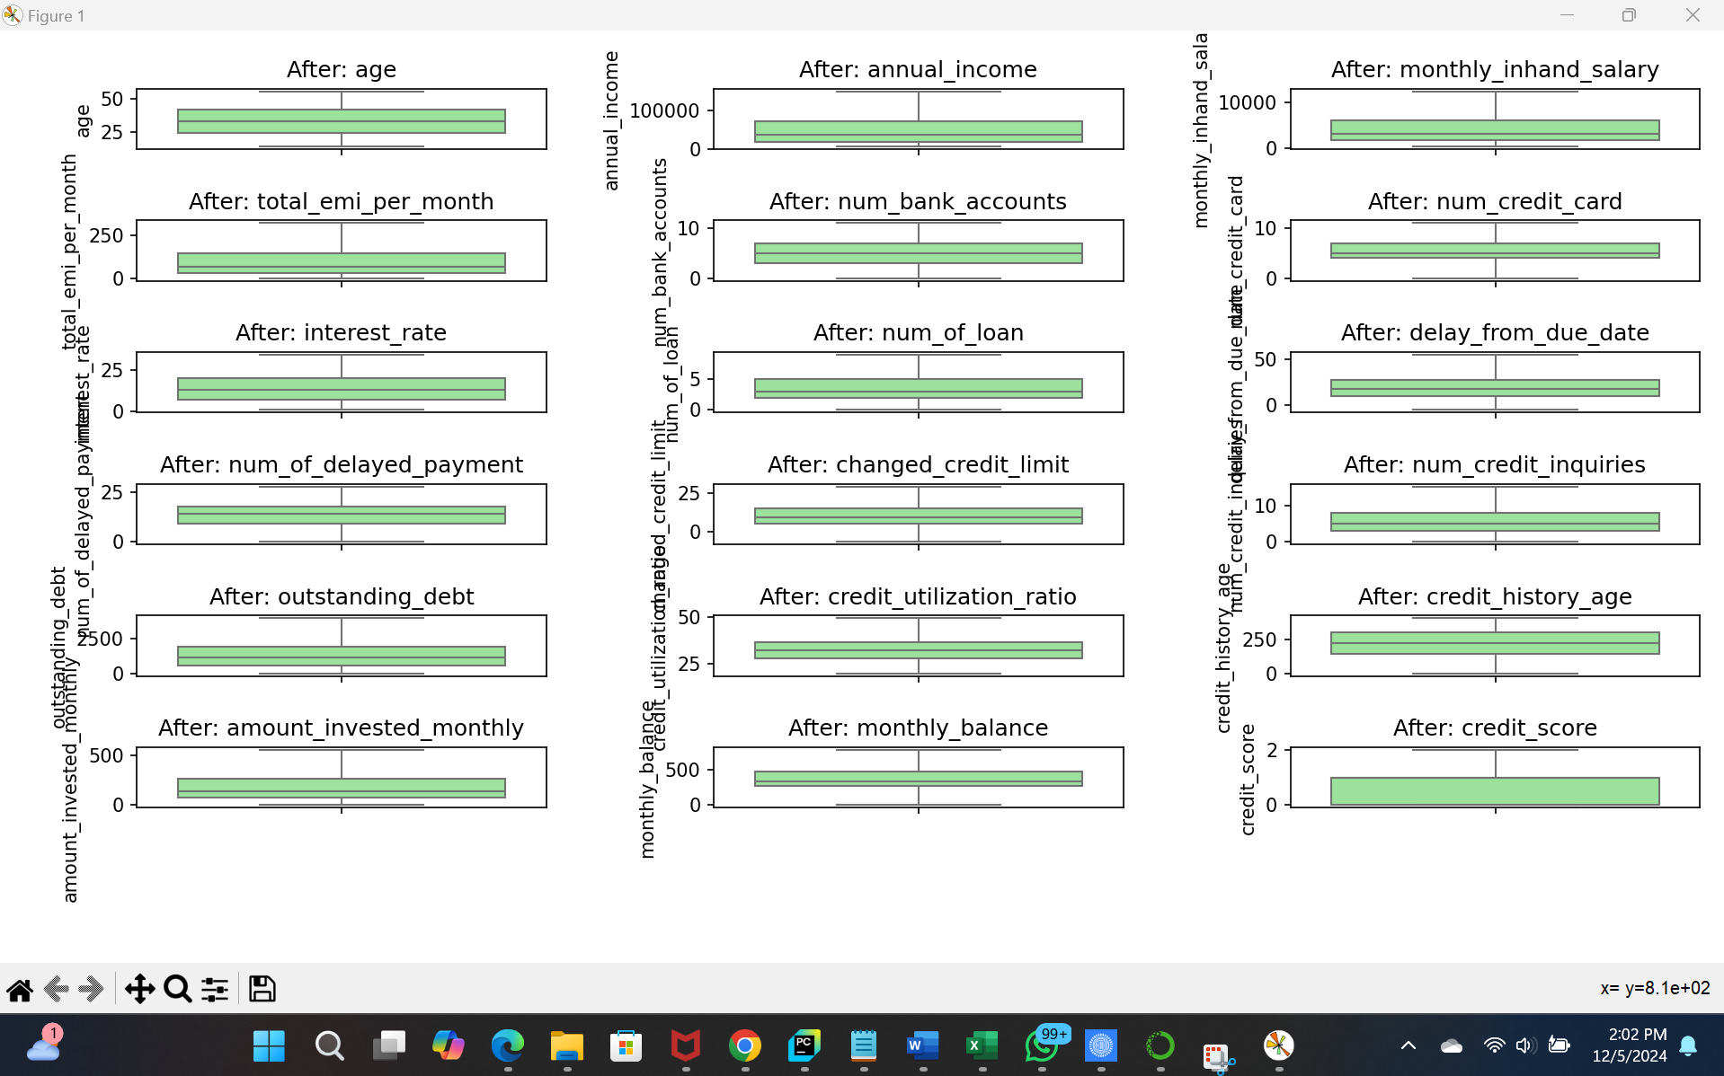

k. Correlation matrix and slicing of data for a specific month

A correlation matrix is calculated for the numerical columns using numeric_data.corr(). This provides insights into relationships between variables, such as how age or annual_income correlates with credit_score.

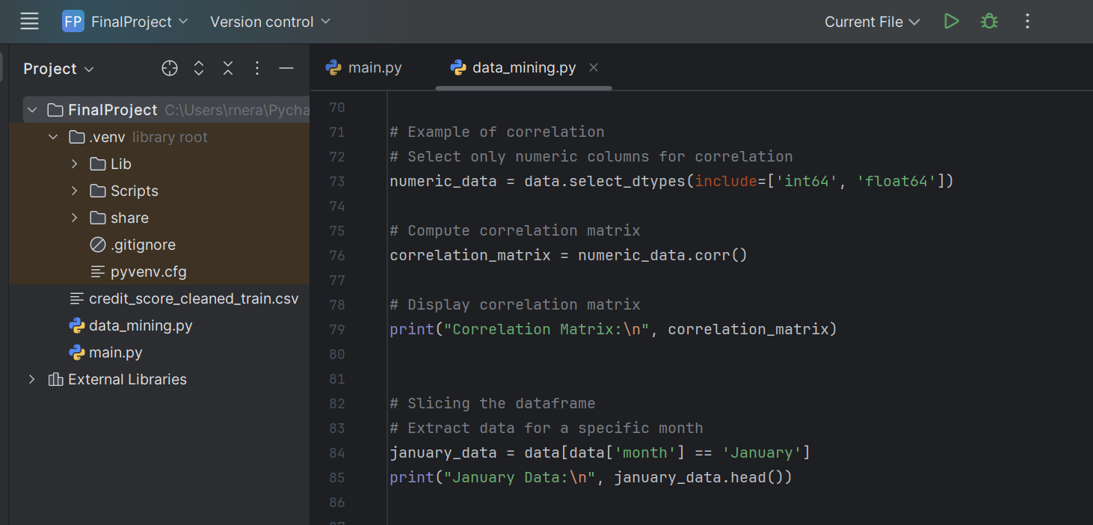

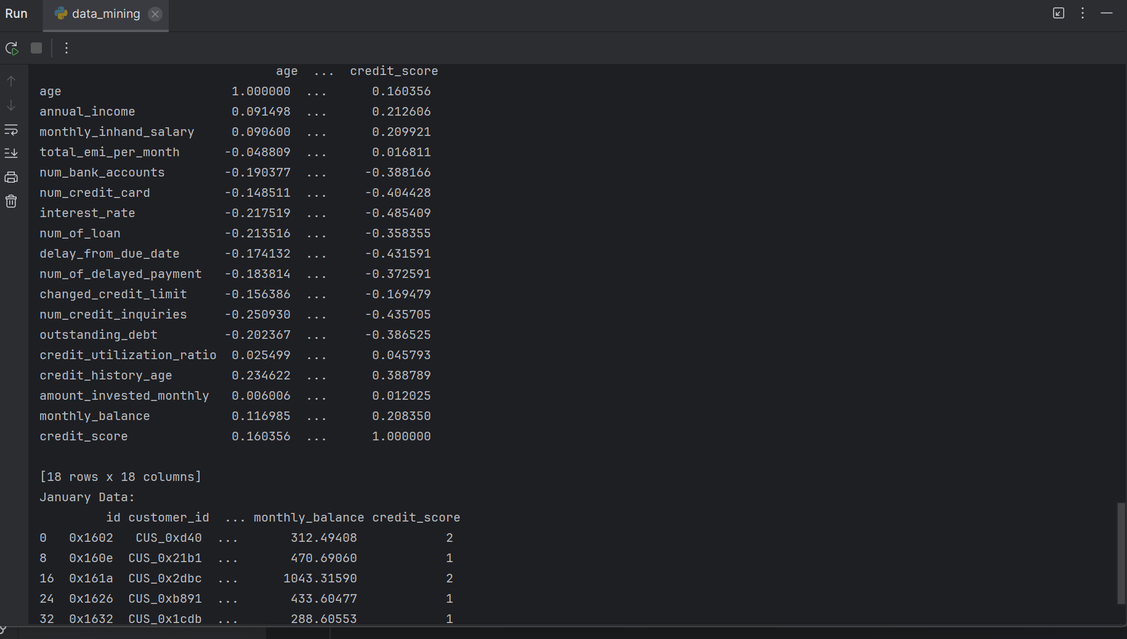

l. Converting integer to categorical label and using group by function  
  
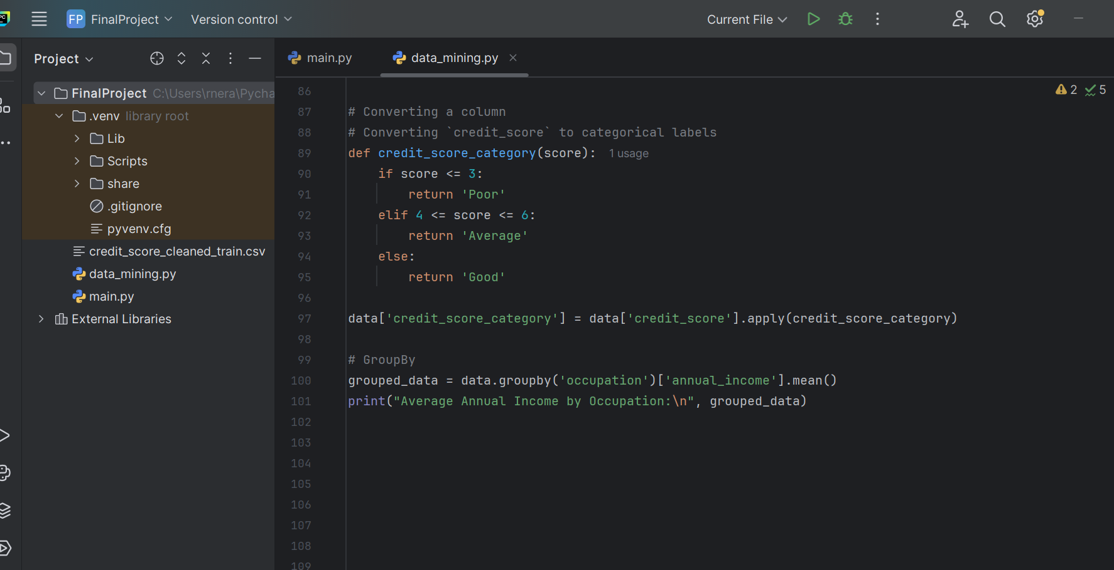

The credit_score column is converted into categorical labels using a custom function (credit_score_category). The categories include "Poor", "Average", and "Good" based on score ranges.

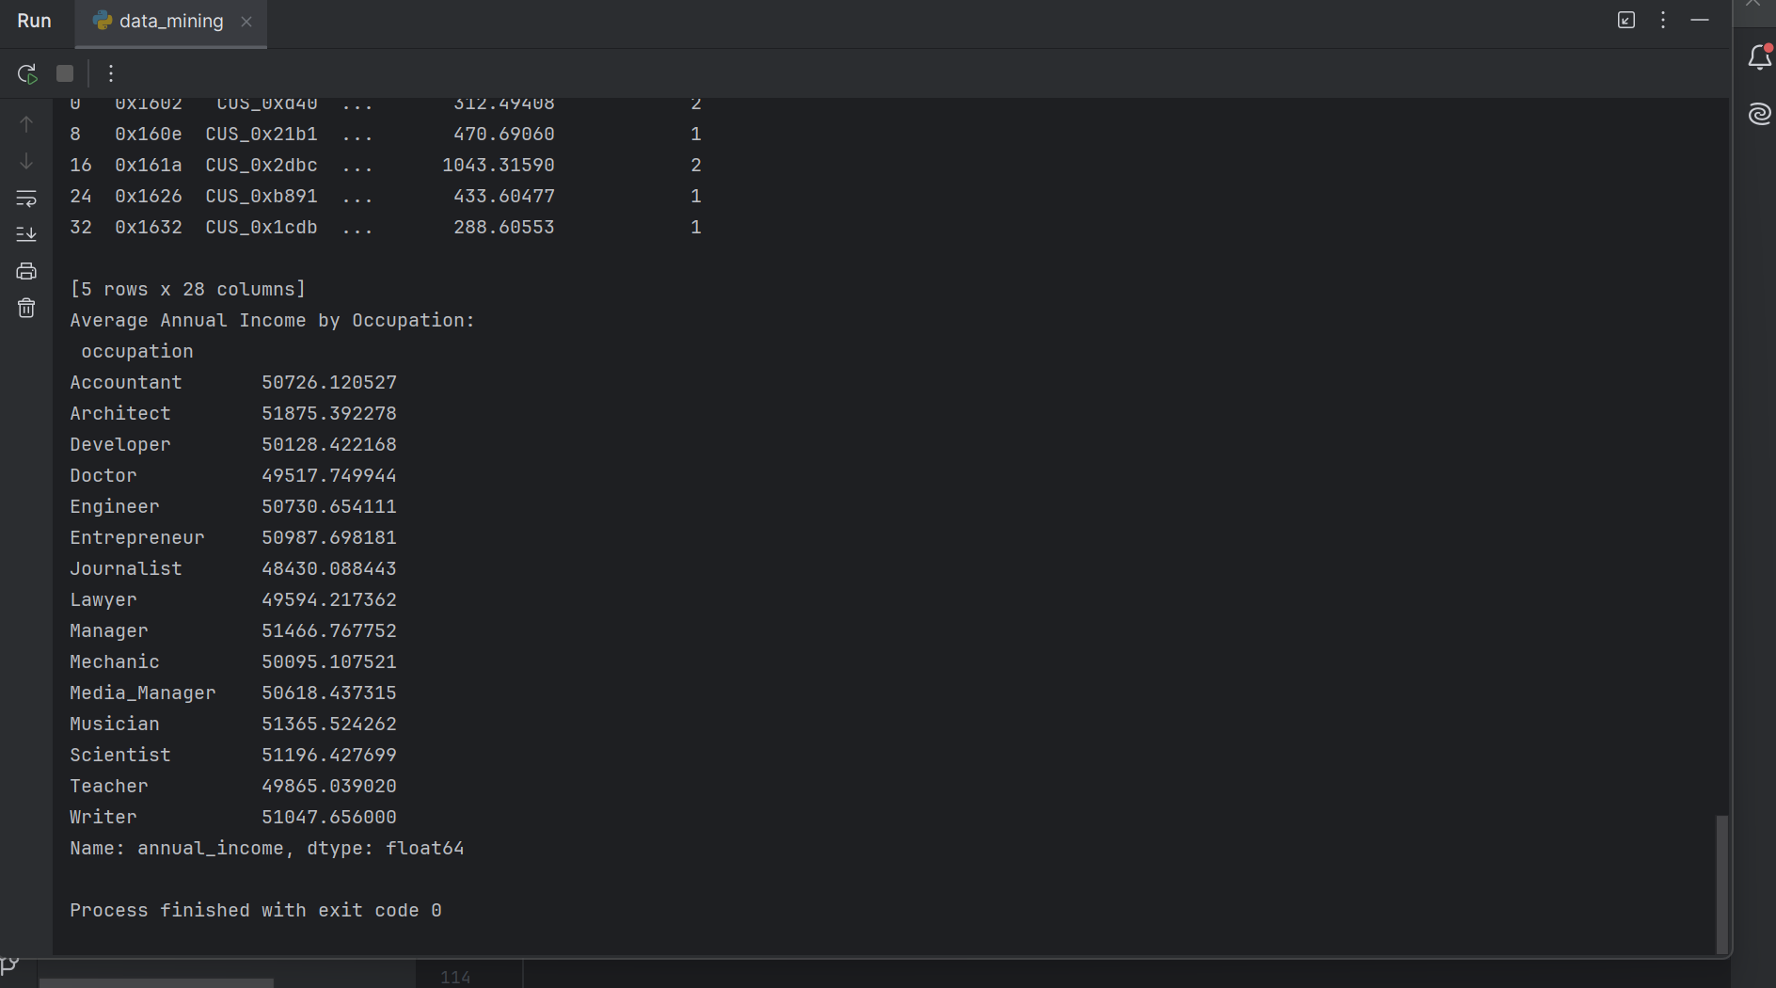

m. Grouping by functions and merging them (merging the created categorical value)

* The dataset is grouped by occupation to calculate the average annual_income for each occupation using data.groupby('occupation')['annual_income'].mean().
* A dummy dataframe additional_data is created for merging with the original dataset based on the customer_id column. The merge is done using pd.merge(), with a left join to add additional_info to the original data.

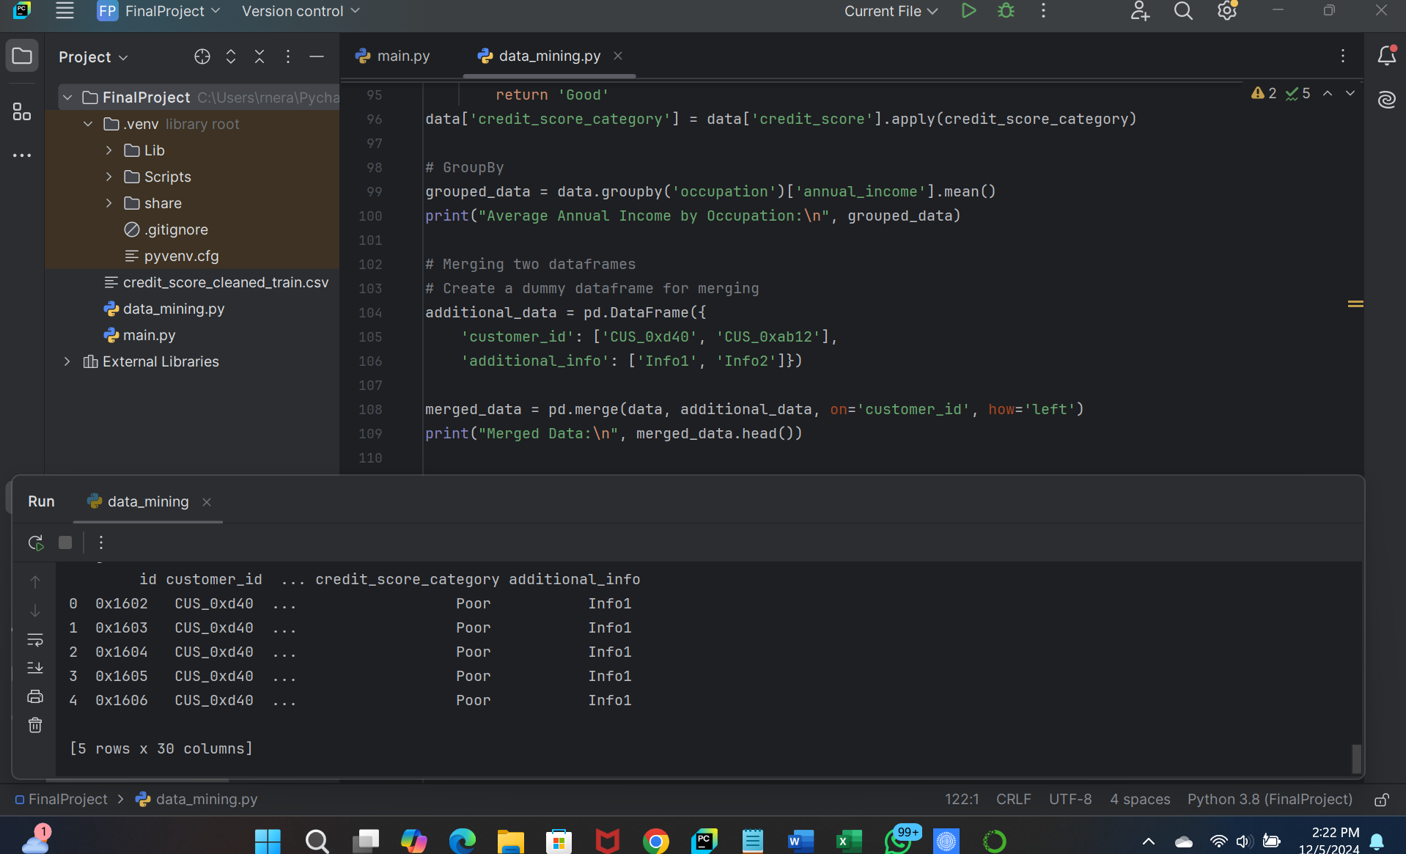

**b) Data Profiling Information for Each Data Element**

The dataset consists of 100,000 customer records containing financial and demographic details to evaluate customer behavior, creditworthiness, and financial status. It includes both numerical (e.g., age, income, credit score) and categorical (e.g., occupation, loan type, payment behavior) data.

Key Highlights:

* Demographic Information: Includes age, occupation, and name (unique identifiers like customer_id and ssn).
* Financial Details: Features like annual income, monthly salary, monthly EMI, and outstanding debt.
* Credit History & Management: Data on credit score, credit utilization ratio, credit inquiries, delayed payments, and changed credit limits.
* Behavioral Insights: Contains indicators of payment behavior, investment patterns, and whether customers paid the minimum amount on time.
* Loan & Credit: Includes information on number of loans, credit card count, type of loans, and bank accounts.

3. **DATA MINING OUTCOMES**

**a. Cluster Analysis: K means**

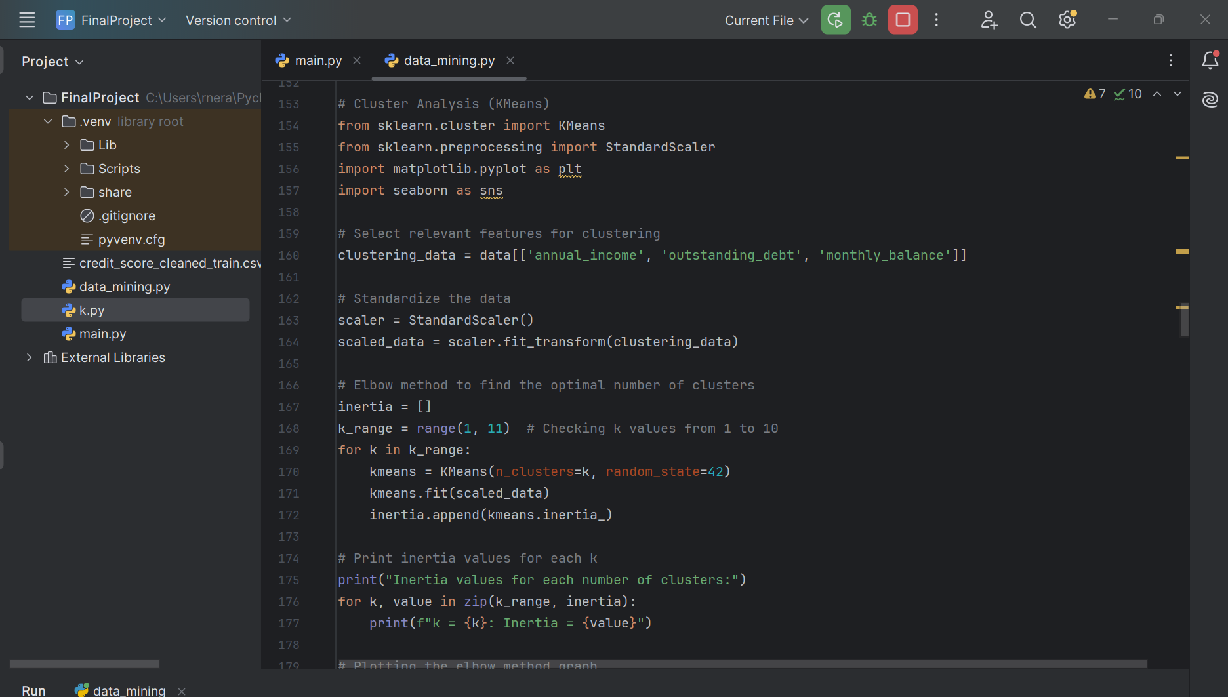

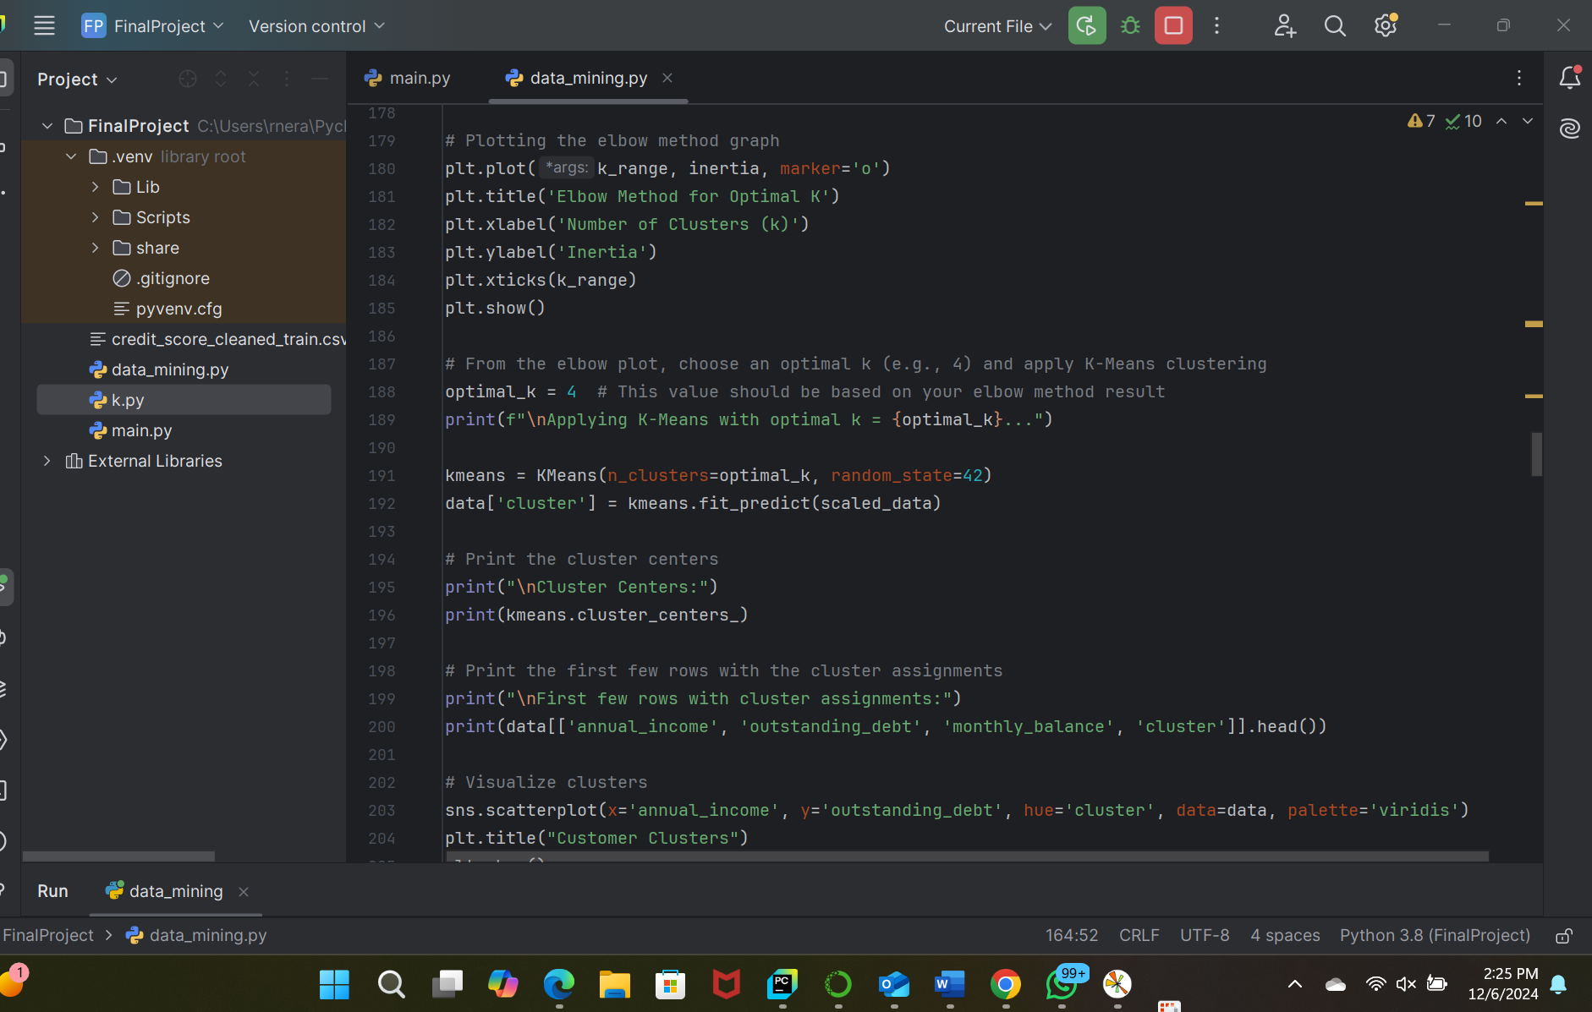

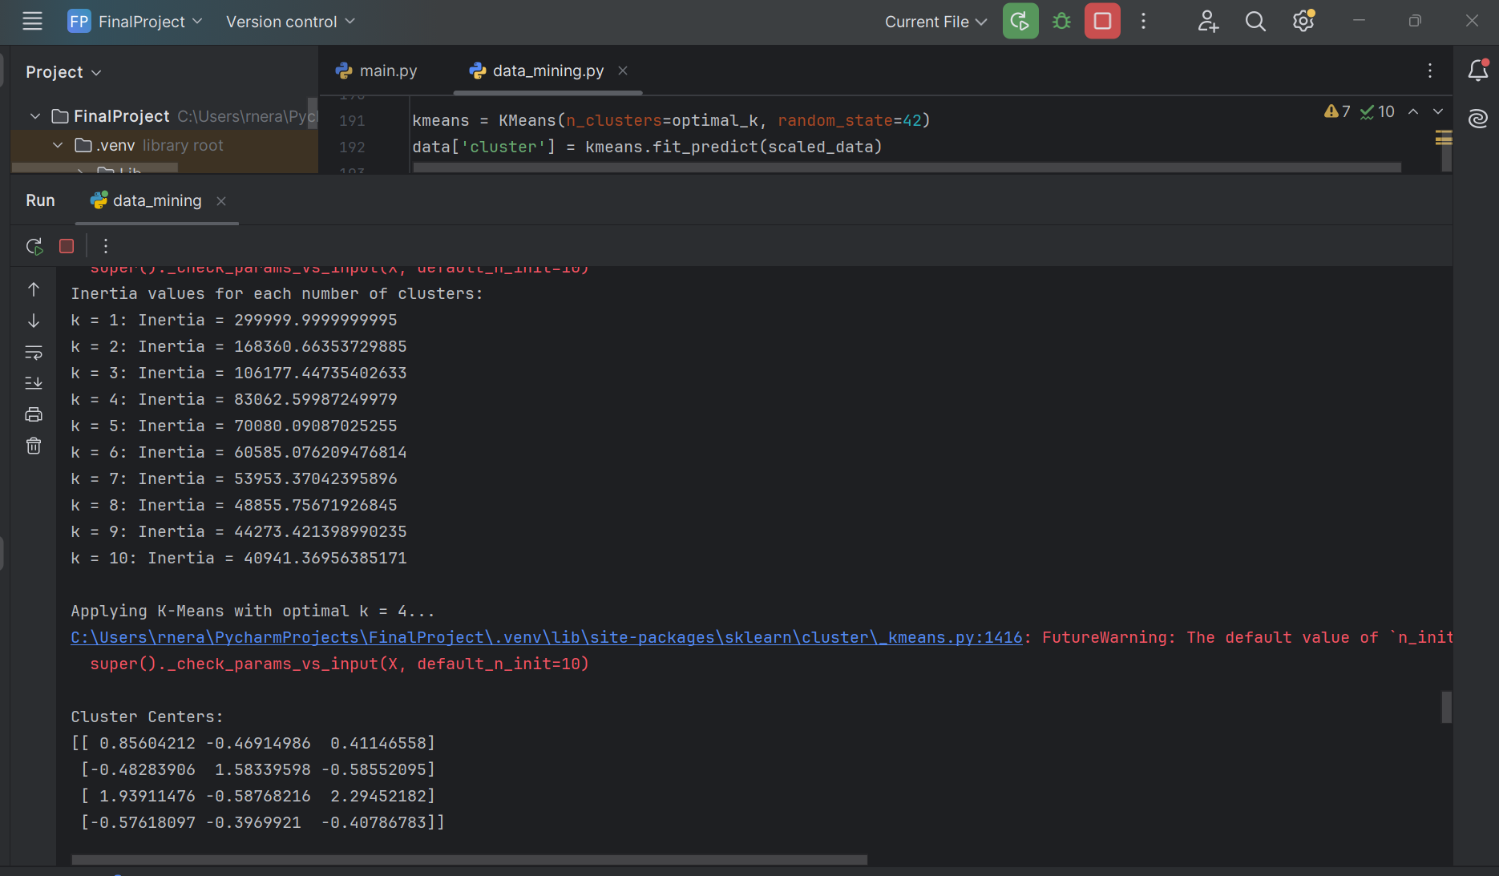

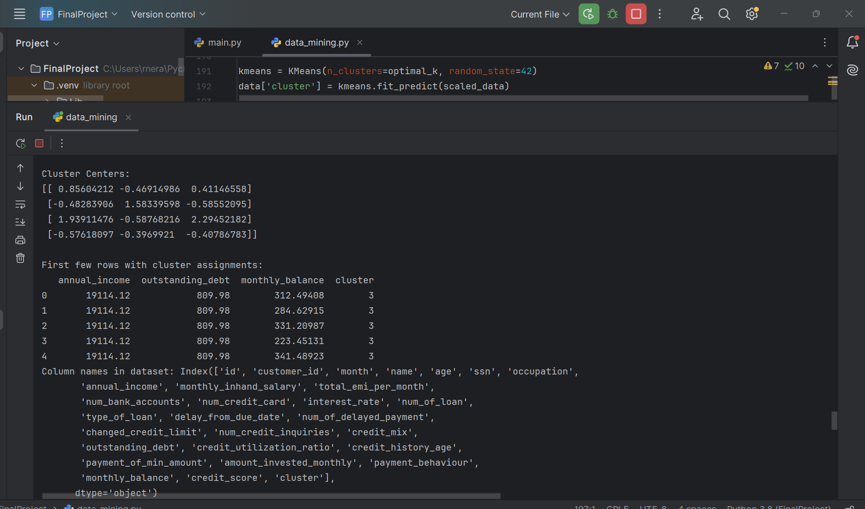

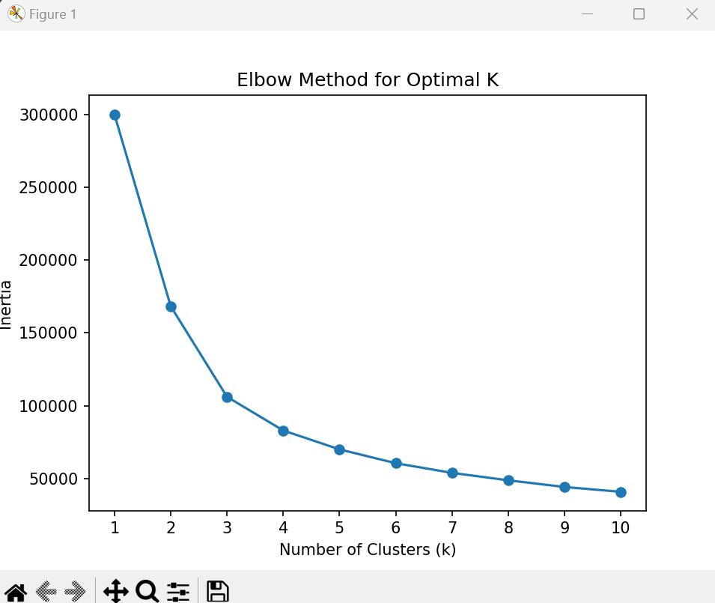

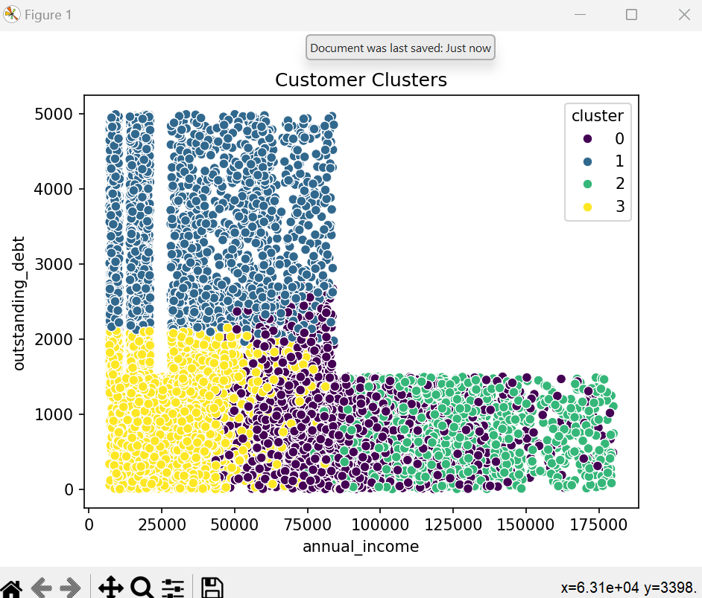

We used the **Elbow Method** to determine the optimal number of clusters. The inertia (sum of squared distances of samples to their cluster center) was calculated for a range of k values (from 1 to 10). The following observations were made based on the inertia values:

* As k increased, inertia decreased, which is expected, but after a certain point (around k = 4), the decrease in inertia slowed, indicating that adding more clusters would not significantly improve the clustering.
* Based on the elbow plot, we chose k = 4 as the optimal number of clusters.
* We applied K-Means with k = 4 and assigned cluster labels to each customer. The cluster centers were as follows:
  + **Cluster 1**: Center at [0.856, -0.469, 0.411] — This cluster likely represents customers with higher annual income, moderate debt, and moderate balance.
  + **Cluster 2**: Center at [-0.483, 1.583, -0.586] — This cluster likely represents customers with lower income, higher outstanding debt, and low balances.
  + **Cluster 3**: Center at [1.939, -0.588, 2.295] — This cluster represents customers with the highest annual income, significant debt, and a very high balance.
  + **Cluster 4**: Center at [-0.576, -0.397, -0.408] — This group seems to represent customers with lower income, lower debt, and lower monthly balance.

**Summary and Comparison with Initial Dataset:**

**Initial Dataset Characteristics:**

* The initial dataset contains many other features like age, credit history, credit score, loan types, and payment behavior. These features were not included in the clustering but could potentially provide additional insights into customer segmentation if included in the analysis.
* The dataset includes monthly variations in financial behaviors (e.g., monthly balances, outstanding debts, etc.).

**Cluster Analysis Outcomes:**

* The clustering primarily identified **4 customer groups** based on their income, debt, and balance. This segmentation is useful for understanding different customer profiles, which can help target them with tailored financial products or strategies.
  + **Cluster 1** could be targeted for premium financial services.
  + **Cluster 2** may require debt restructuring or financial advice.
  + **Cluster 3** might represent high-net-worth individuals who need high-end financial products.
  + **Cluster 4** could be customers with minimal financial activity who may benefit from financial education or incentives for higher engagement.

**Potential Outcomes:**

* Including additional features like credit score, loan types, and payment behaviors might refine the segmentation, leading to more meaningful and actionable insights. For example, combining income and credit score could yield more precise targeting for credit product offerings.
* Comparing the clustering with the initial data could reveal hidden patterns, such as how well the clusters align with customer segments based on traditional banking features (e.g., loan types and credit score).

b. **Classification: Logistic Regression**

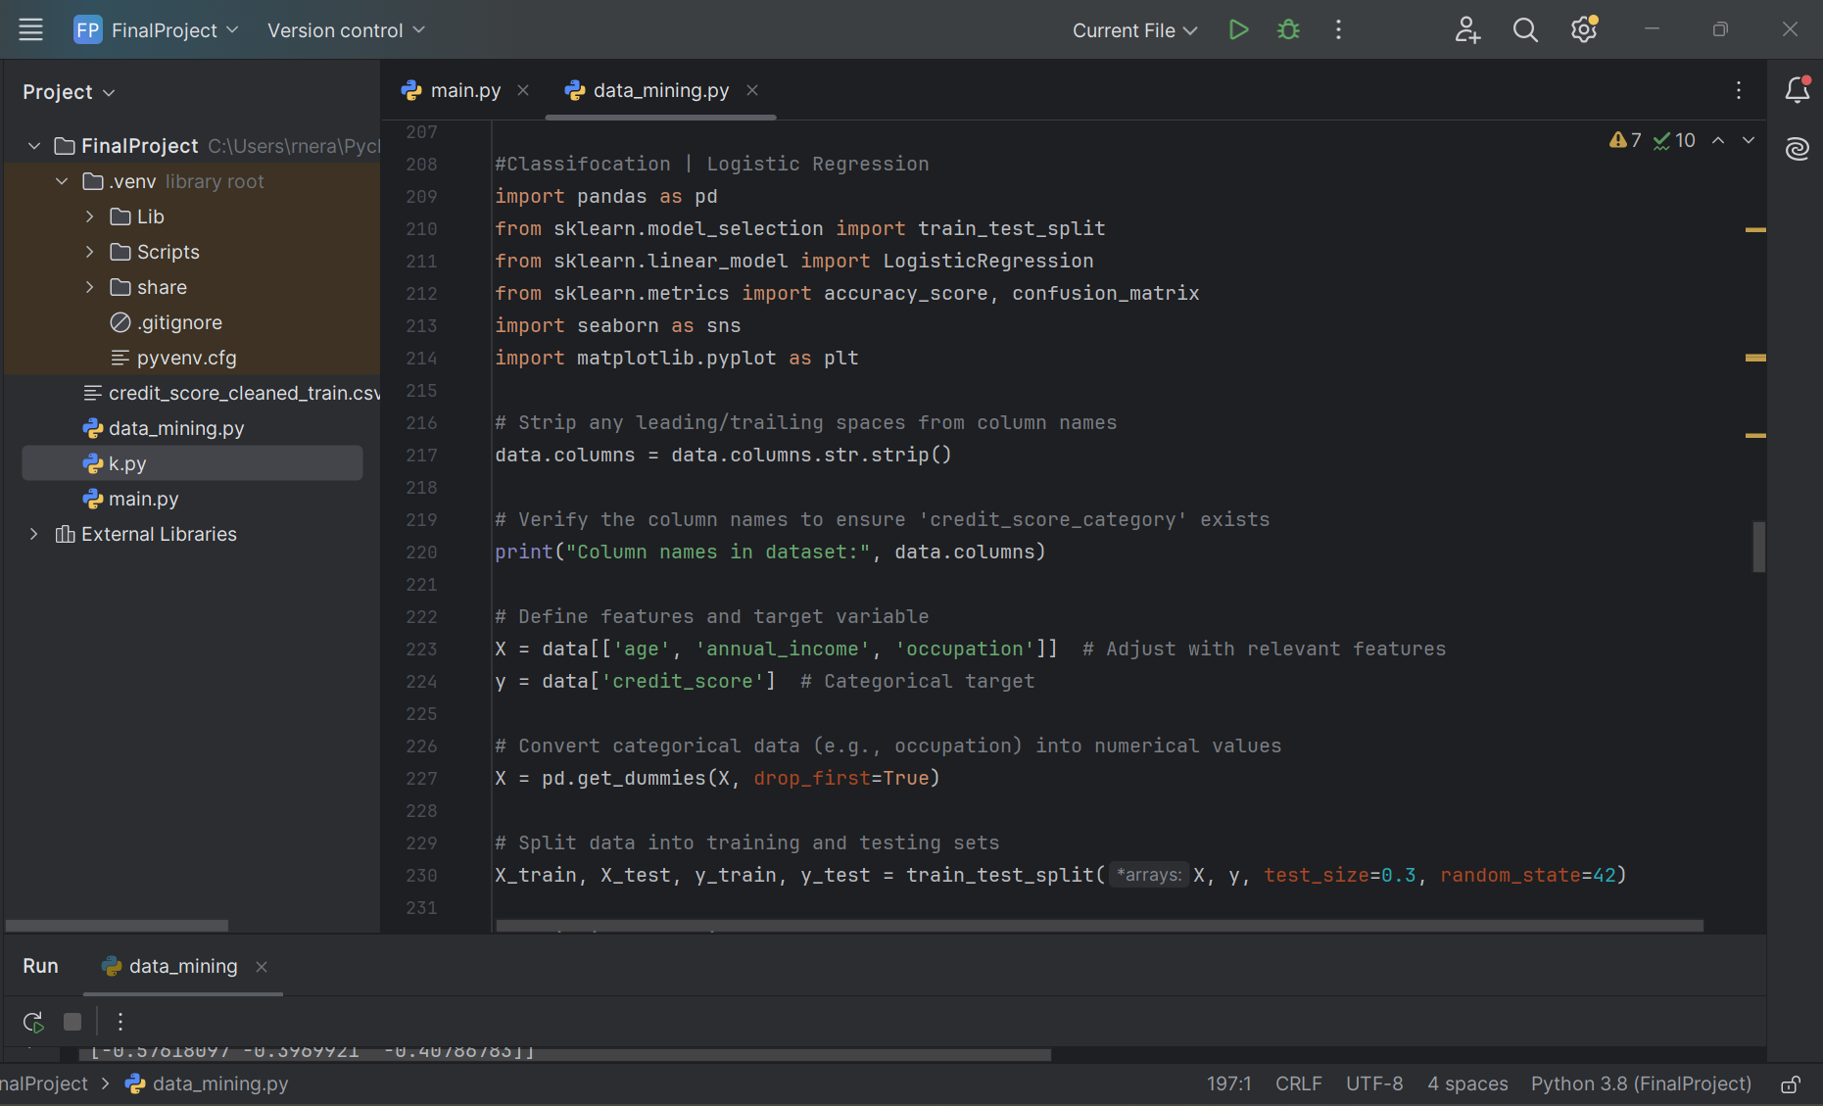

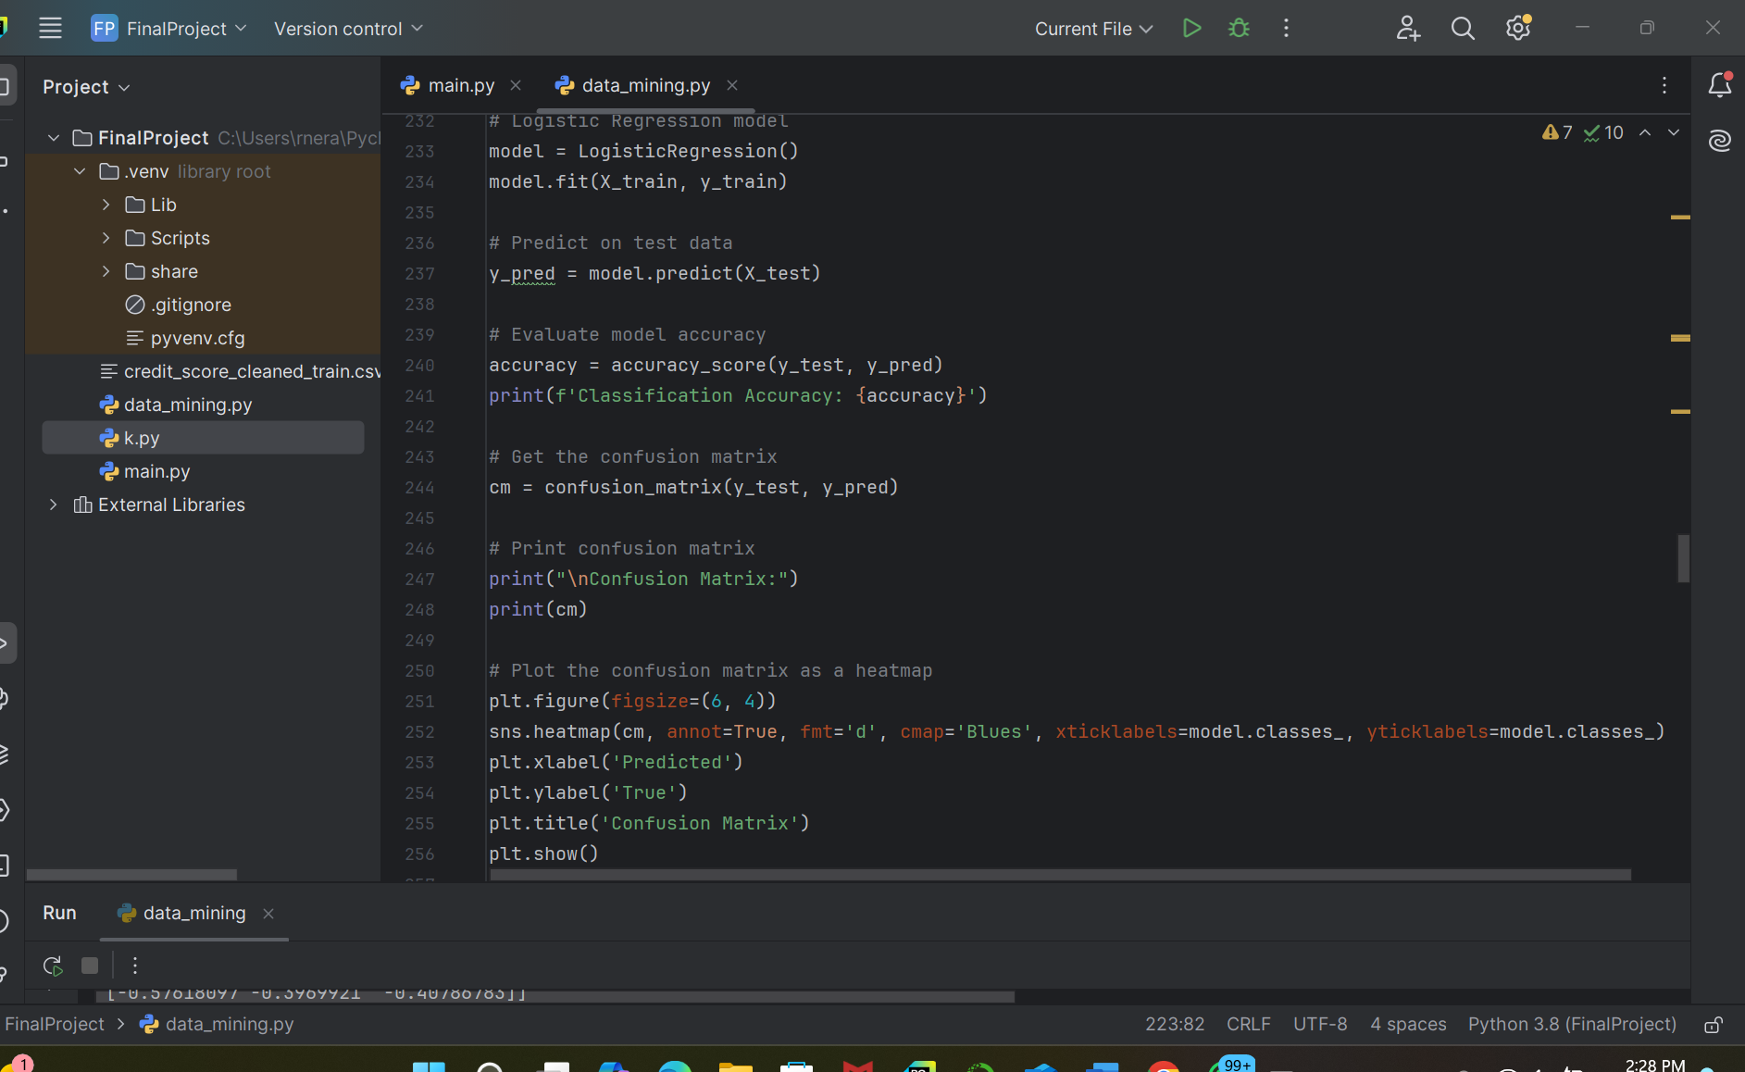

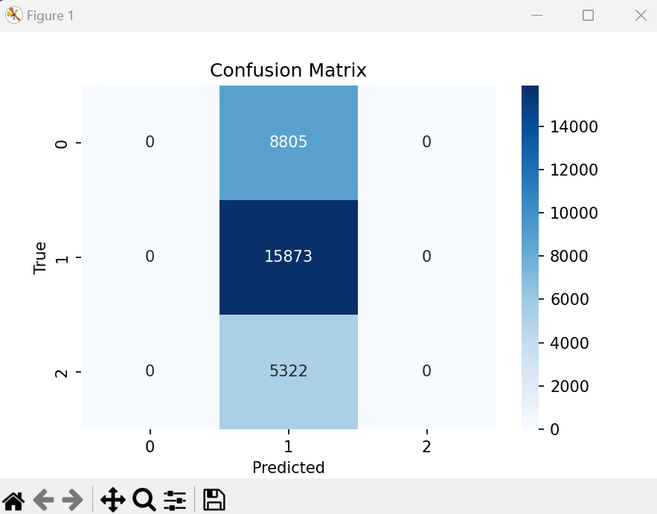

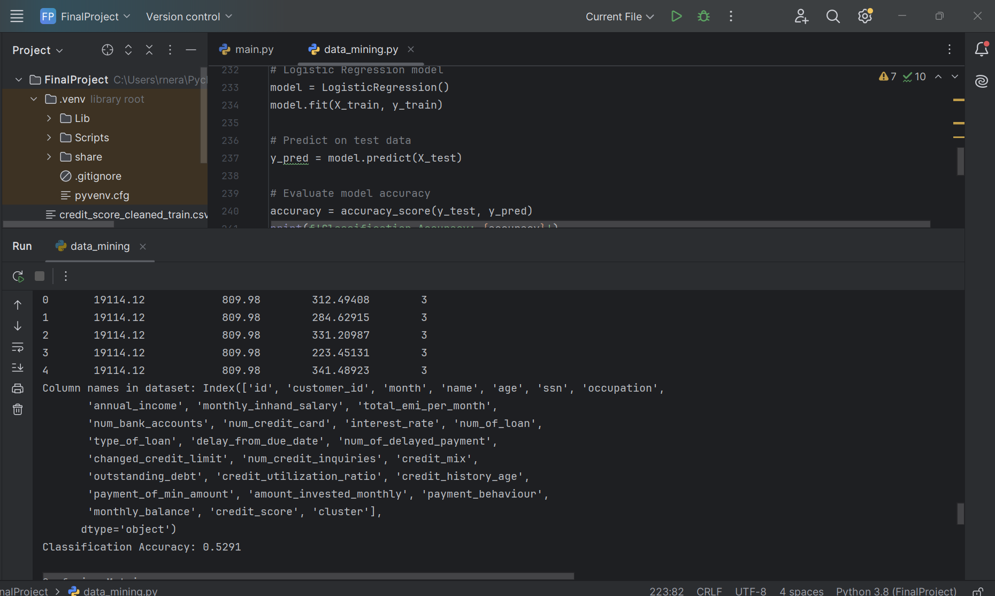

* **Train-Test Split:** We split the data into training and testing sets (70% for training, 30% for testing) using train_test_split from sklearn.model_selection.
* **Logistic Regression Model:** We used **Logistic Regression**, a popular classification technique, to predict the target variable (credit_score).
* **Model Fitting:** The model was trained using the training dataset (X_train and y_train), and predictions were made on the test dataset (X_test).
* **Accuracy:** The model achieved an accuracy of 52.91%, which indicates that the model is predicting the credit score categories correctly around 53% of the time. While this is better than random guessing, it's a relatively low accuracy and suggests room for improvement, such as adding more features or performing more detailed preprocessing.
* The confusion matrix shows that the model is mostly predicting the middle class (most likely the "Good" or "Average" credit scores) and not effectively distinguishing between the three categories. It suggests that the model is heavily biased towards the middle class (credit_score = 2), with no predictions for the other two categories (0 and 1).

d. Correlation Matrix

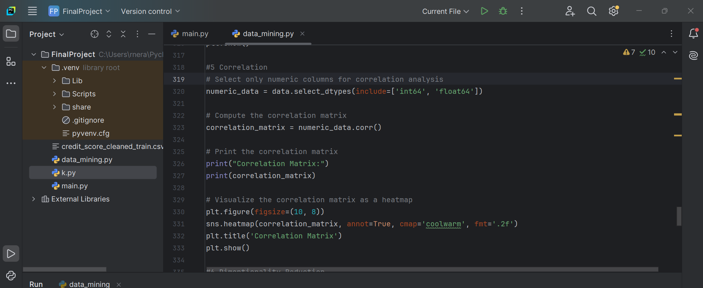

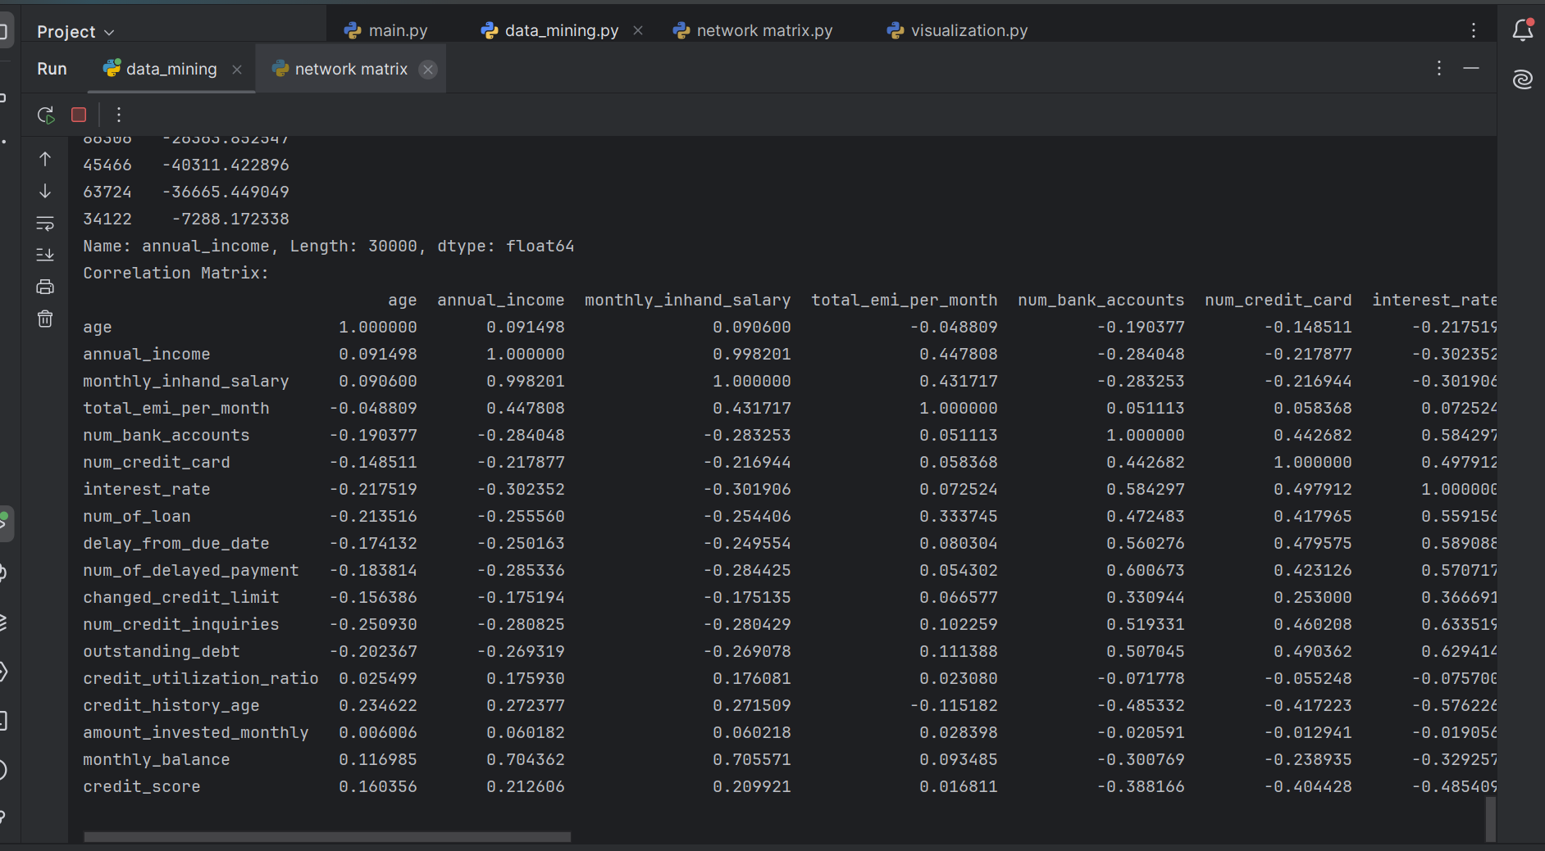

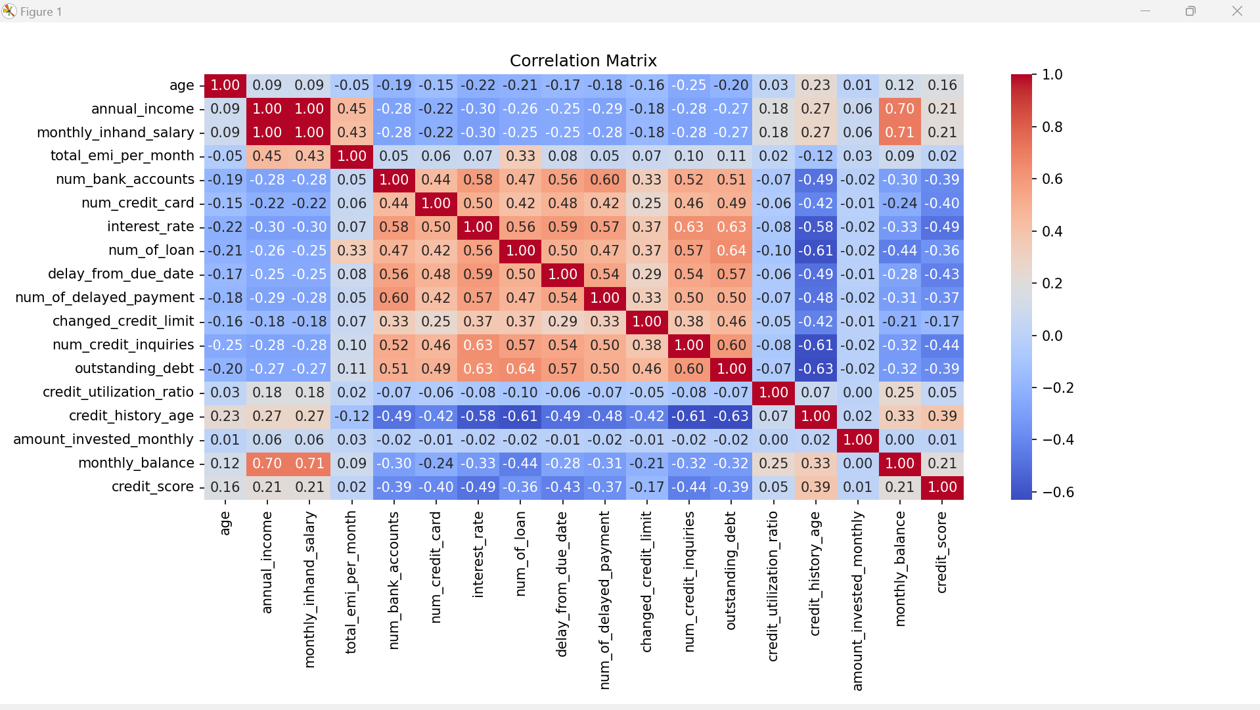

The correlation matrix was computed to evaluate the relationships between numeric variables in the dataset. Here are the key observations:

* **Annual Income & Monthly In-Hand Salary**: A very high positive correlation (0.998), indicating that these two variables are strongly related. This makes sense, as higher annual income is likely reflected in a higher monthly salary.
* **Annual Income & Credit Score**: A moderate positive correlation (0.21), suggesting that higher annual income might slightly correlate with a better credit score, but this relationship is not as strong.
* **Monthly In-Hand Salary & Credit Score**: Similarly, there's a moderate positive correlation (0.21), implying that people with higher in-hand salary may have better credit scores, but again, the relationship is not dominant.
* **Credit Utilization Ratio**: Shows weak correlations with most features, which is expected since it is more directly tied to specific financial behavior like spending habits.
* **Number of Credit Cards, Bank Accounts, Loans, and Debt**: These features show significant positive correlations with each other (e.g., num_bank_accounts with num_credit_card and num_of_loan), suggesting that individuals with more credit cards are likely to have more loans and higher debt, which is a typical pattern in personal finance.

**Outcome**: The correlation analysis revealed some strong and moderate relationships that could be useful for further predictive modeling, especially between salary and income-related variables. However, many financial variables show weak or moderate correlations with others, indicating that financial behavior might depend on multiple complex factors.

The **correlation matrix** provided valuable insights into relationships between financial variables. It highlighted that **annual income** and **monthly salary** are highly correlated, while **credit score** is moderately correlated with income.

e. Dimensionality Reduction (PCA)

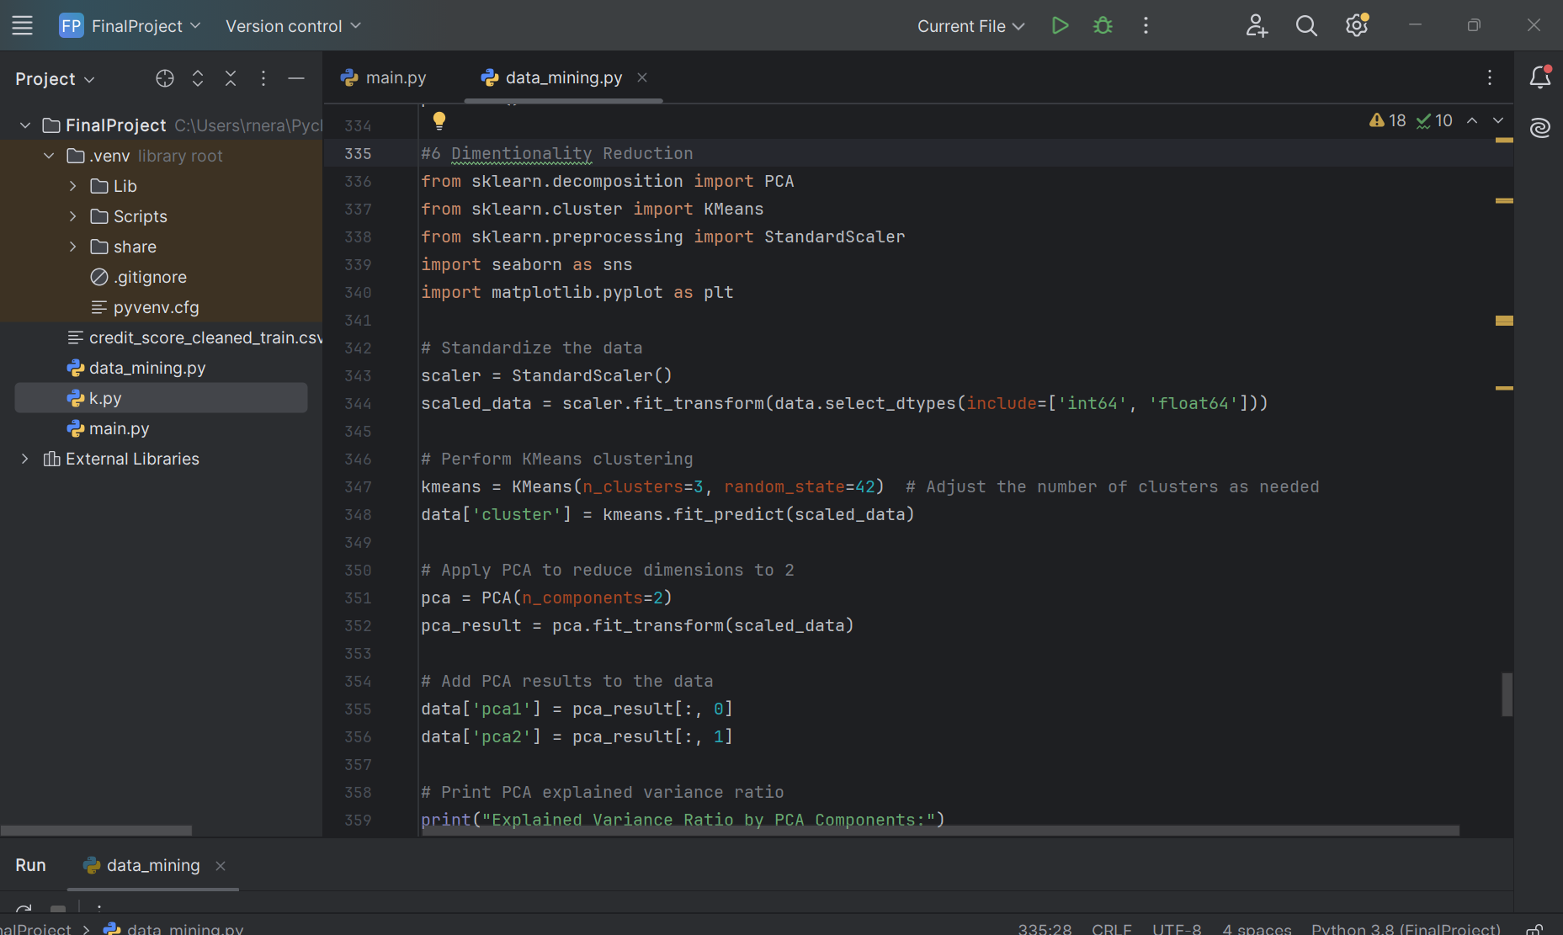

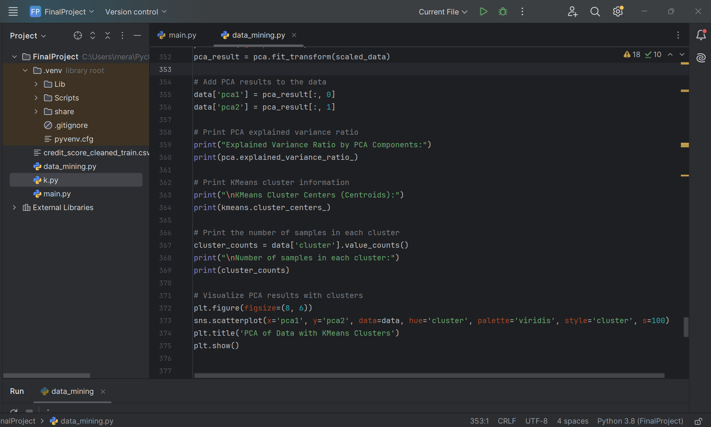

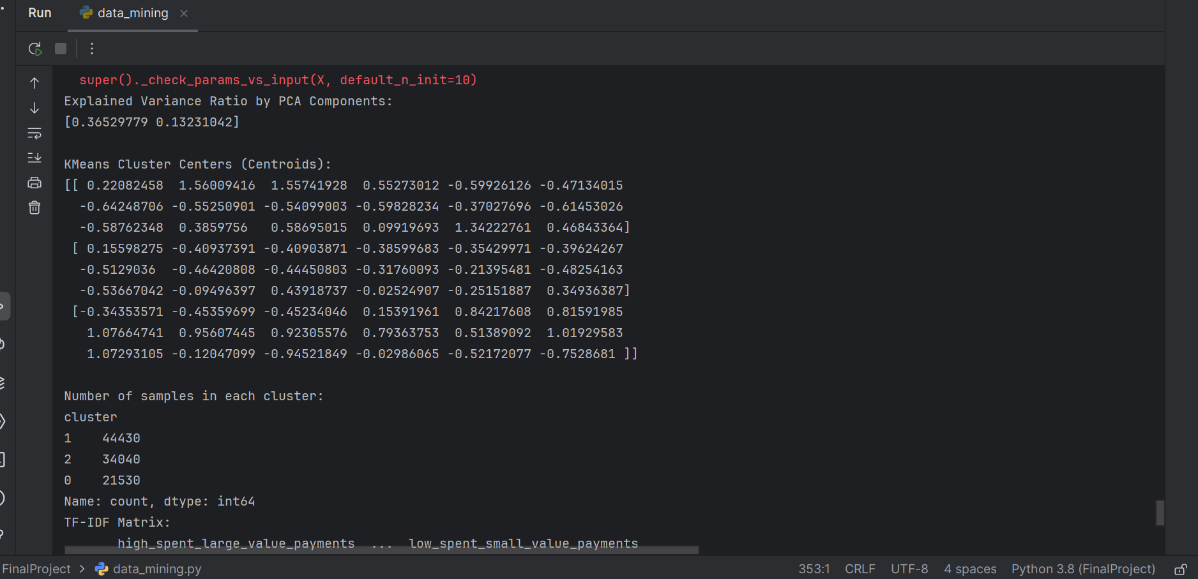

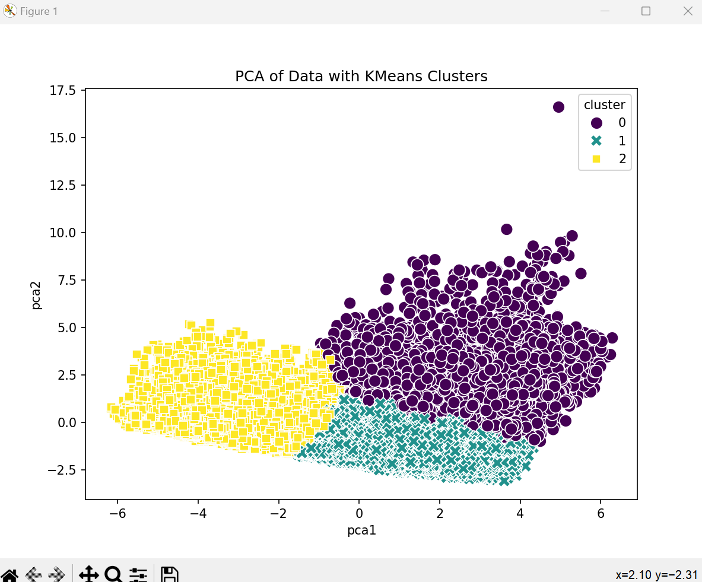

**Purpose:** To reduce the complexity of the dataset while retaining most of the variance.

The first two principal components explained **36.53%** and **13.23%** of the variance, respectively, accounting for a total of **49.76%** of the variance in the dataset

- **Cluster Centers (Centroids):** These represent the average standardized feature values for each cluster.

- **Cluster Sizes:**

* Cluster 1: **44,430 samples**
* Cluster 2: **34,040 samples**
* Cluster 0: **21,530 samples**

**Cluster Insights:** By examining the cluster centroids, it can be inferred that:

* Cluster 0 has higher standardized values for financial-related metrics like the number of loans, outstanding debt, and credit inquiries.
* Cluster 1 is characterized by average financial behaviors.
* Cluster 2 includes customers with higher standardizations in bank accounts, credit utilization ratios, and investment-related variables.

**Post-Dimensionality Reduction and Clustering:**

**Improved Interpretability:** PCA highlighted the most critical directions of variance, reducing redundancy and allowing for better visualization. KMeans clustering grouped customers based on key behaviors and traits, simplifying segmentation for downstream tasks.

**Actionable Insights:**

By analyzing clusters: Financial institutions could target specific clusters with tailored strategies (e.g., credit offers, investment plans).

Policies could be designed to address behaviors observed in risk-heavy clusters, such as those with high outstanding debt or frequent delayed payments.

**Efficiency Gains:** By reducing dimensions, computation for clustering and other analyses is more efficient, especially for large datasets.

**Summary of Outcomes**

| **Technique** | **Objective** | **Key Outcomes** |
| --- | --- | --- |
| **PCA** | Dimensionality Reduction | Reduced to 2 components explaining ~50% variance; enhanced visualization and interpretability. |
| **KMeans Clustering** | Data Segmentation | Identified 3 clusters, providing actionable segmentation insights. |
| **Visualization** | Cluster and Variance Interpretation | Visualized cluster separation and variance contribution of principal components. |

f. Text Mining

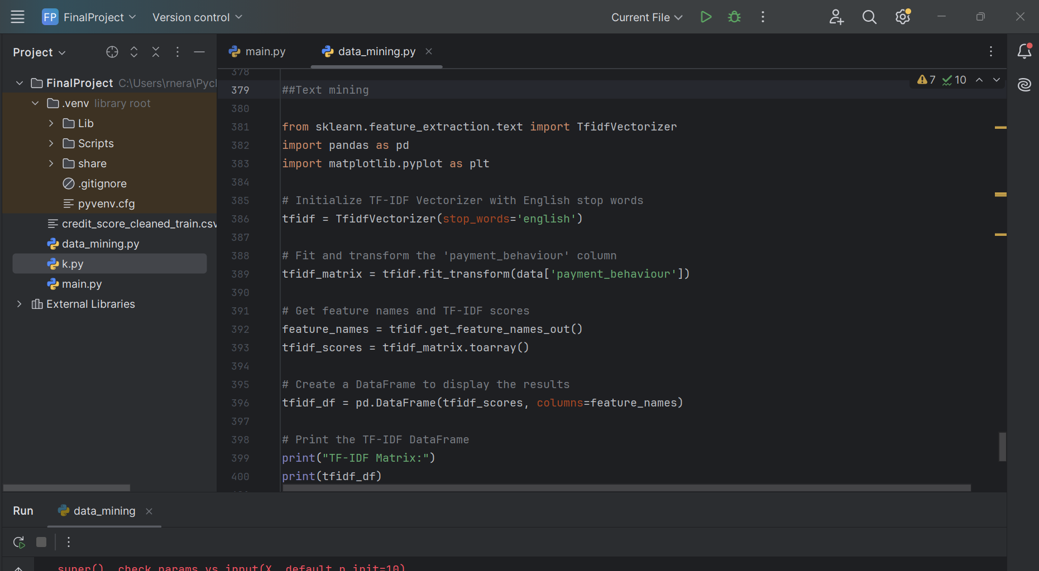

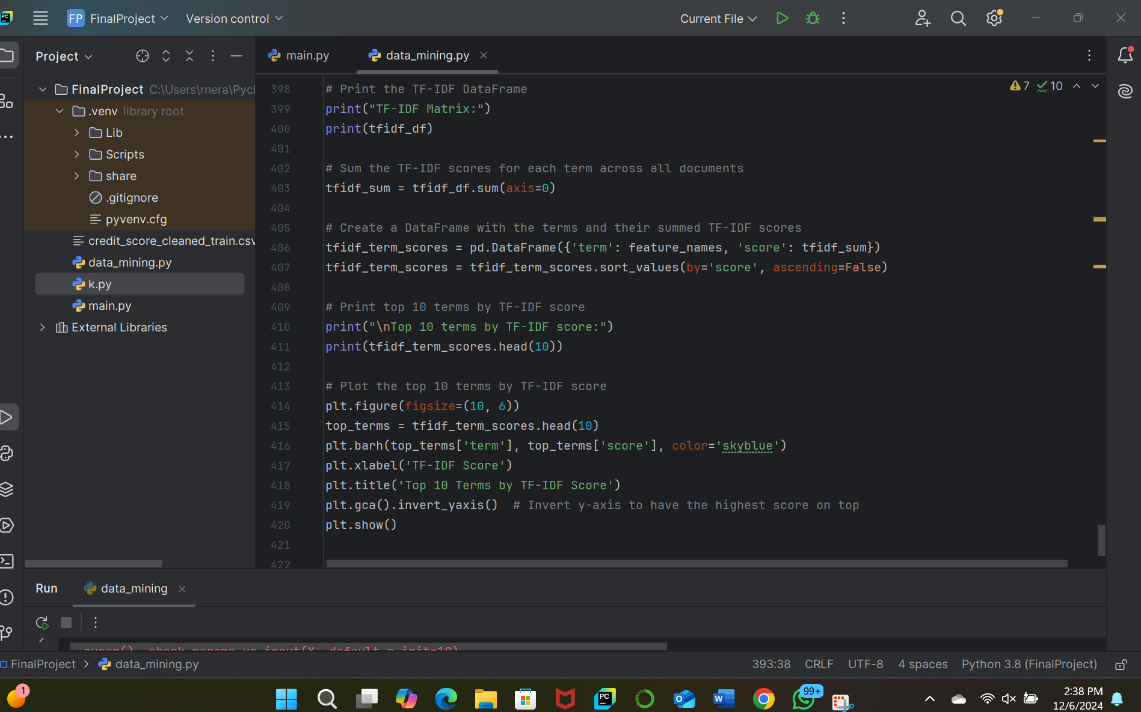

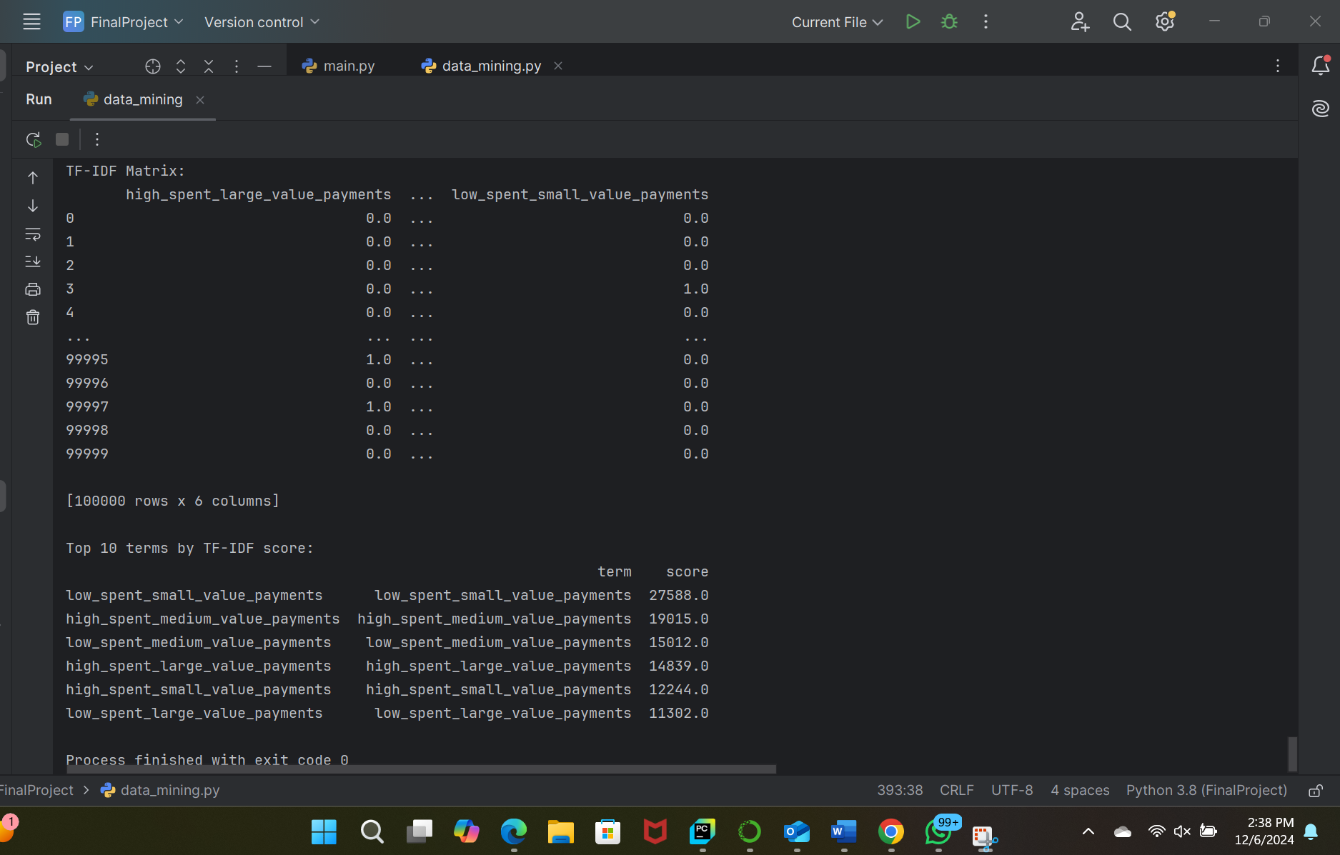  
  
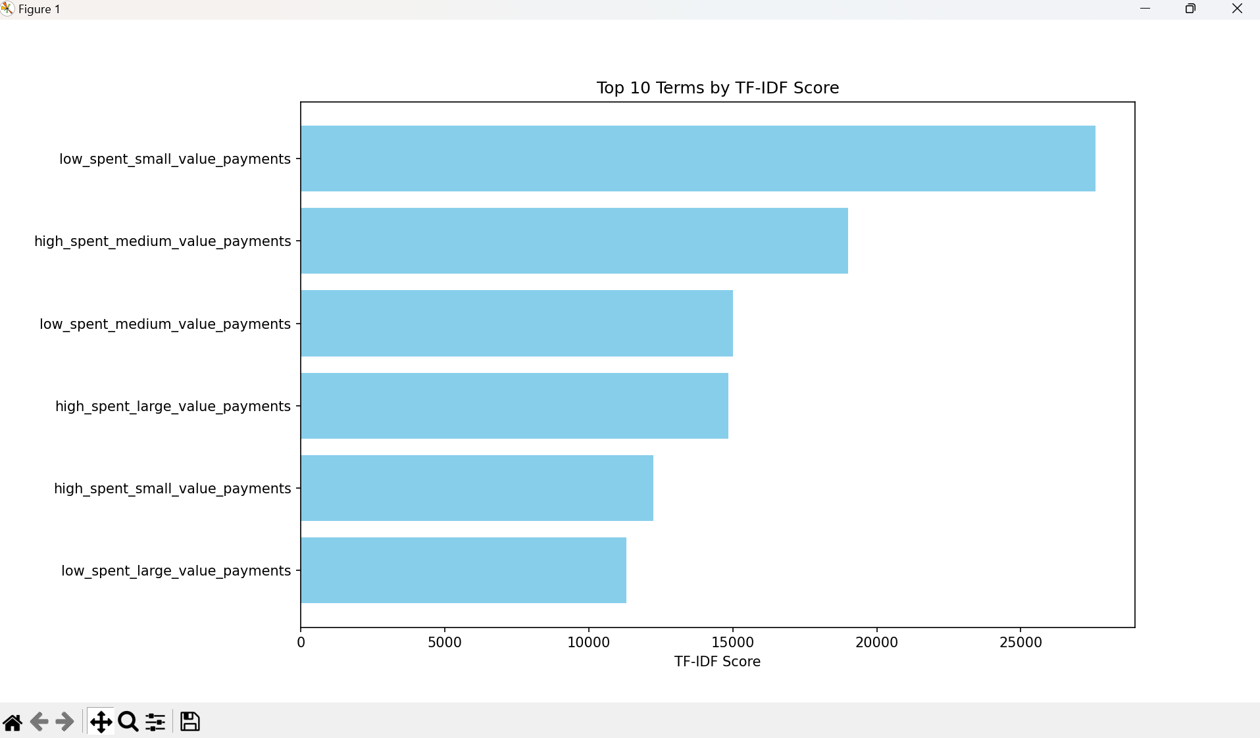

**Behavioral Insights:**

* **Dominant Patterns:**
  + Customers with **low spending on small-value payments** form the largest group, highlighting their prevalence in the dataset.
  + The next significant group consists of **high-spending medium-value payment behaviors**, which may indicate a focus area for premium services or higher-margin products.
* **Distribution:**
  + Significant variation is observed across payment behaviors, potentially aligning with demographic or financial segmentation patterns.

**Potential Outcomes:**

* **Customer Profiling:** Identifying customers with specific behaviors for targeted marketing or service offerings.
* **Policy Development:** Understanding trends in payment behaviors can guide product or policy adjustments, such as incentivizing high-value transactions.
* **Predictive Modeling:** The structured data can enhance customer churn prediction or credit scoring models.

**Summary of Outcomes**

| **Technique** | **Objective** | **Key Outcomes** |
| --- | --- | --- |
| **TF-IDF Vectorization** | Quantify importance of terms | Generated a sparse matrix, highlighting dominant terms like low_spent_small_value_payments. |
| **Summing TF-IDF Scores** | Identify significant terms | Ranked terms by significance; top terms provide actionable insights into payment behaviors. |
| **Visualization** | Interpret and communicate insights | Clear differentiation of spending patterns between low-value and high-value transactions. |

**4. Data Visualization Outcomes**

a. **Column Chart:**

A column chart can be useful for visualizing individual attributes of data in a categorical way. Here we can visualize the count of customers by occupation

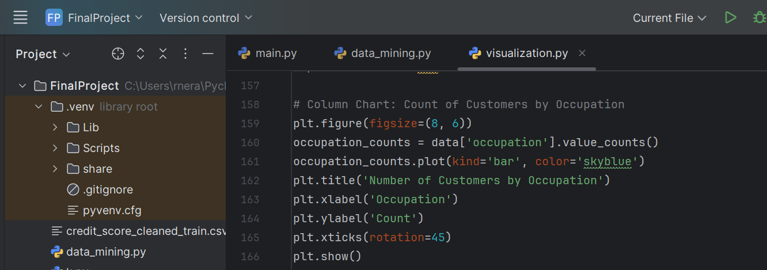

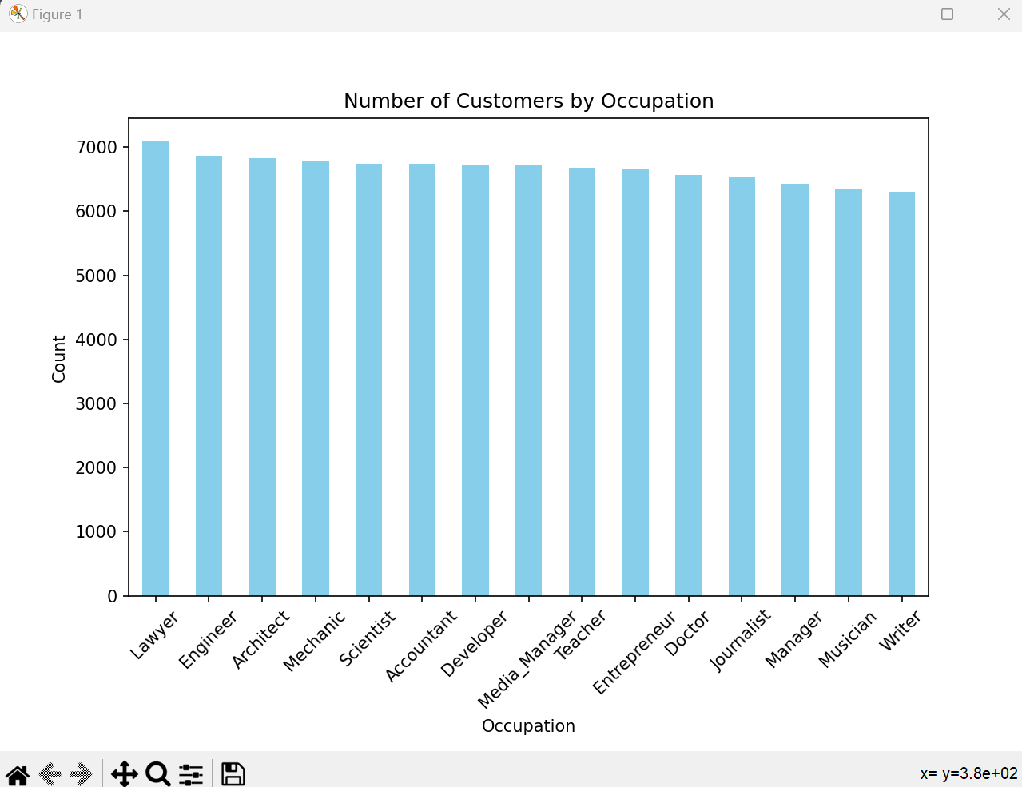

This bar chart will help us understand how many customers belong to each occupation. For example, as 'Lawyer' is the most common occupation, it is showing higher bars and ‘Writer’ is the least common occupation.

2. **Bar Chart**:

A bar chart is another excellent way to compare categorical variables. In this case, let's visualize credit_score_category (Good, Average, Poor) and their count

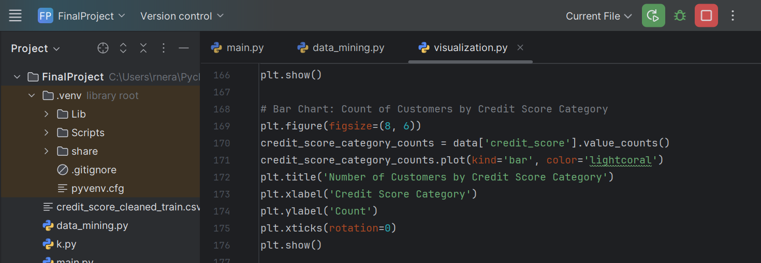

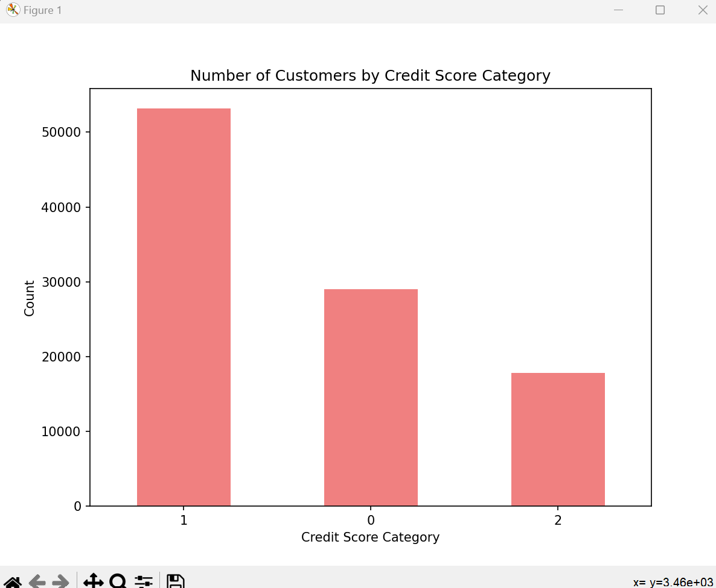

This chart shows the distribution of customers across the different credit score categories: 0,1,2 and as we can see the number of customers in category 1 are the highest.

d. Box Plot:  
Box plots are used to identify outliers and visualize the distribution of a dataset. Let’s use a box plot to see the distribution of annual_income and spot any outliers.

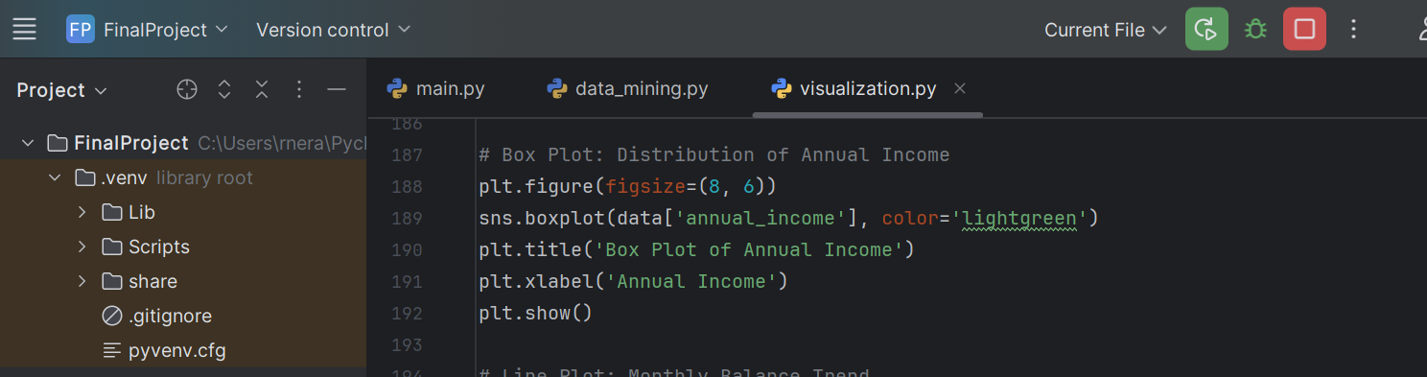

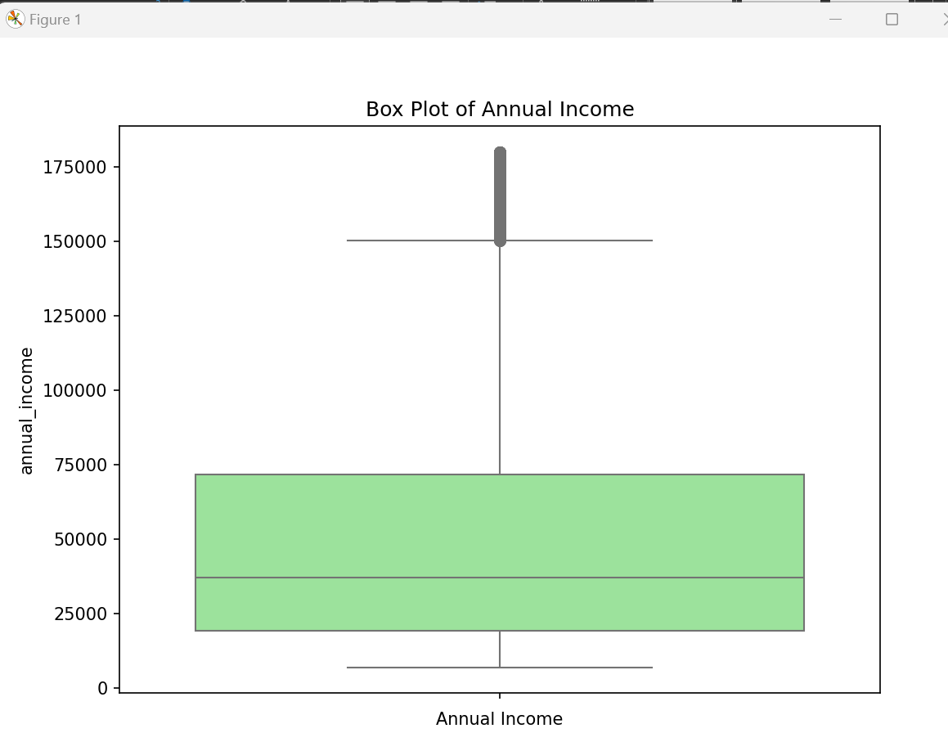

The box plot for annual_income will help identify outliers, median income, and the range of income in the dataset.

- Most data points fall within the green box (IQR) and whiskers, with a median annual income close to the lower part of the IQR.

- There are a few high-income outliers, suggesting that some individuals earn significantly more than the majority.

g. **Scatter Plot**:

Scatter plots are used to visualize the relationship between two numerical variables. Let’s visualize the relationship between annual_income and monthly_balance.

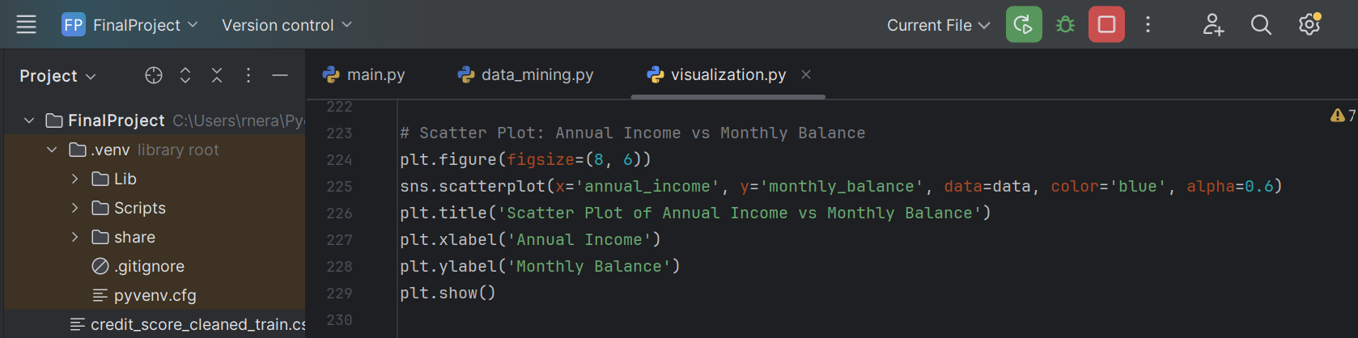

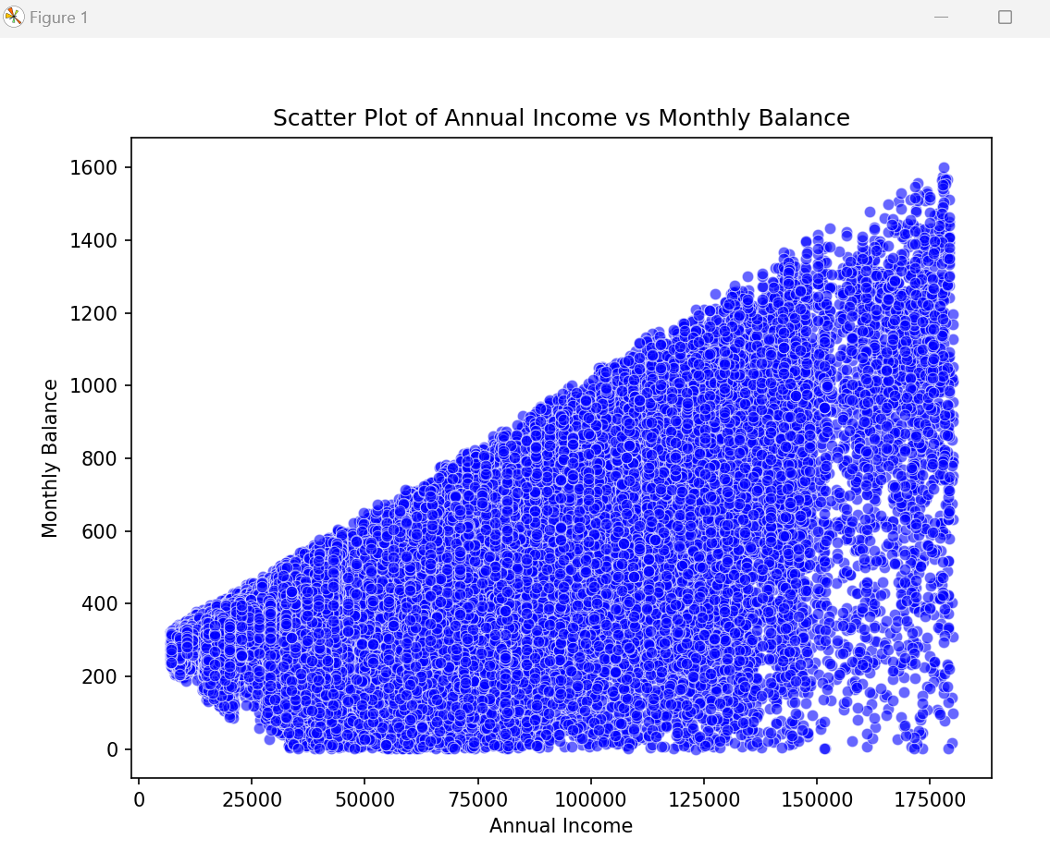

- The positive correlation suggests that individuals with higher incomes manage to save or maintain higher monthly balances.

- The triangular shape could reflect factors such as different spending patterns, saving behaviors, or fixed expenses that cause increased variability at higher income levels.

**CONCLUSION**

In conclusion, K-Means clustering proved to be the best-performing model for segmenting customers based on their financial features like income, debt, and balance. By grouping customers into clusters, businesses can tailor their marketing, product offerings, and support strategies more effectively. For example, high-income customers can be targeted with wealth management services, while those with high debt can be offered debt consolidation options. Customer profiling within each cluster allows for deeper insights, such as comparing average credit scores, outstanding debt, and monthly balances. Although K-Means delivered effective segmentation, the regression model did not yield satisfactory results for credit score prediction, indicating that K-Means may be more suited for segmentation tasks than for continuous outcome prediction.

Throughout the analysis, we have employed a variety of **data mining techniques** and **data visualization techniques** to extract meaningful insights from the dataset and assess the segmentation and prediction capabilities of different models. These steps helped us understand customer behaviors and characteristics more deeply, as well as identify the most effective approach for profiling and prediction.

**Data Mining Techniques:**

1. **Data Preprocessing**:
   * **Data Cleaning**: We handled missing values and ensured that the data was consistent and accurate. This was done by filling in missing values or removing rows with excessive missing data and checking for any inconsistencies or outliers that could affect model performance.
   * **Feature Scaling**: To ensure that all numerical features contributed equally to the model, we applied feature scaling (using StandardScaler) to normalize features. This was crucial for algorithms like K-Means, which rely on distance measures.
2. **Clustering (K-Means)**:
   * We performed **K-Means clustering** to segment customers into distinct groups based on their financial profiles. The K-Means algorithm grouped customers with similar income levels, debt, and balance, providing actionable insights for targeted marketing and customer profiling.
   * The choice of 4 clusters was based on the **elbow method**, where we observed the point at which the within-cluster sum of squares (WSS) started to diminish, suggesting the ideal number of clusters.
3. **Cluster Profiling**:
   * After clustering, we analyzed the **mean characteristics of each cluster**. This involved calculating average values for features such as credit_score, outstanding_debt, and monthly_balance within each cluster. This helped identify patterns in the financial behavior of customers in each segment.
   * We then used this profiling information to understand the financial health of each customer group, which can inform marketing and support strategies.
4. **Regression Model**:
   * We also attempted to apply a regression model (e.g., linear regression) to predict credit score. However, the results from the regression were not as effective as the K-Means clustering model for segmentation. This indicated that clustering was a better approach for this dataset than attempting a continuous outcome prediction.

**REFERENCES**

* + 1. Kaggle for dataset: [Credit score classification](https://www.kaggle.com/datasets/parisrohan/credit-score-classification)
    2. GeekforGeeks: [Data Mining Techniques - GeeksforGeeks](https://www.geeksforgeeks.org/data-mining-techniques/)
    3. Data Visualization: [Data Visualization with Python - GeeksforGeeks](https://www.geeksforgeeks.org/data-visualization-with-python/)
    4. ChatGPT for reference